Do
Study
Act
Plan
PDSA Cycle Worksheet

Cycle # | Date of Test: | Date of Completion:
Overall Project Aim:

What is the objective of the test?

PLAN:

Brief description of the test
Describe test of change | Person responsible (Who) | When to be done | Where to be done

What key driver does the change impact?

How will you know that the change is an improvement & how will I collect data?
List of tasks needed to complete | Person responsible (Who) | When to be done | Where to be done

What do you predict will happen?
Your prediction of what will happen when test is carried out | Measures to determine if prediction succeeds

DO:

Test the change: Was the cycle carried out as planned?

Yes No

What did you observe that was not part of the plan?

STUDY:

Did the results match your prediction?

Yes No

Compare the results of your test to your previous performance:

ACT:

Decide to Abandon, Adapt, or Adopt.

Abandon: Discard change idea and try a new one.

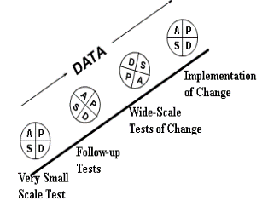
Adapt: Improve the change and continue testing. Describe what you will change in your next PDSA cycle.

Adopt: Select changes to implement on a large scale and develop an implementation plan for sustainability.

If you plan to adopt, what plans do you have for your next 2-3 PDSA cycles for follow-up tests and implementation:

