USF / TAMPA GENERAL / MOFFITT / JAHVA
Computer and Application Resources

Below is a list of resources to help resolve issue you may encounter in the event of Computer problems, Epic (USF and/or TGH), CERNA (Moffitt) and CPRS (James Haley VA) and other application problems for 2019-20 incoming residents and fellows.

USF HEALTH
Here are a list of resources you can access to help resolve issue you may encounter in the event of Computer problems or Epic and other application problems.
- Questions about Epic Training for USF Health Care, email the Clinical Systems Training Team:
  - training@health.usf.edu

- For TipSheet for when you are rotating through a USF Department, visit the Epic Sharepoint website:
  - https://epic.health.usf.edu > Click Epic Documentation link

- For Epic Support while at a USF Department, email the Clinical Systems Support Team:
  - epicsupport@health.usf.edu

- For help with Computer-related issues, i.e. VMWare, HSCNet Passwords, etc., contact the Health IT HelpDesk:
  - 813-974-6288, opt 1
  - http://health.usf.edu/is/

- To review online eLearning Modules for Epic at USF, visit the Saba website:
  - https://usf.sabacloud.com
    - Login using your USF Health user name and password
    - In the search bar search for keyword: Resident
    - Click on Resident Online Course
    - Click on: Enroll and launch the Epic modules.
    - If required to do so you may also find Additional Resident Training modules to complete by searching for keyword: Additional
    - Click on Additional Resident Training
    - Click on: Enroll and launch the modules.

- Question regarding e-learning modules, please contact training@health.usf.edu
Reminder: while you are working at a USF Clinic, when logging into Epic you must select the correct role by clicking on the magnifying glass below.

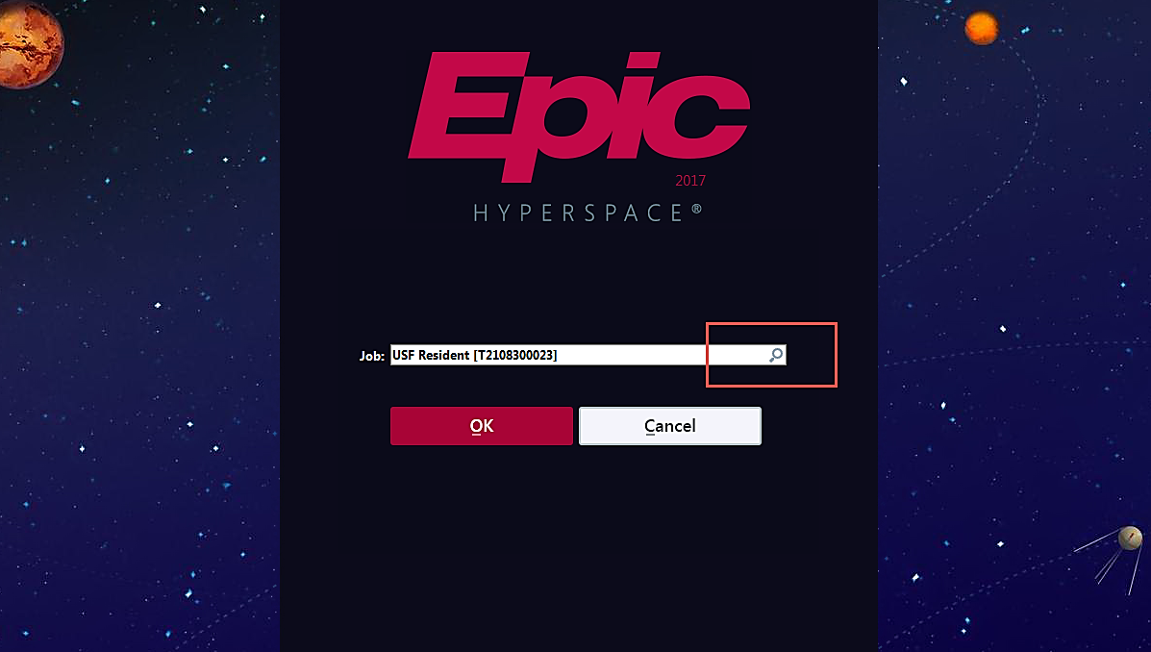

At the Job selection window, choose the magnifying glass and select your job function. While at a USF Department (Outpatient) use the USF Resident and when at TGH (Inpatient) use the TGH Resident/Fellow

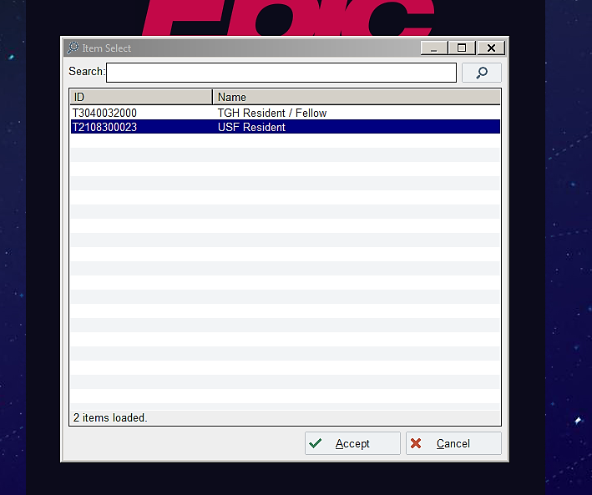

Logging off the Epic application is extremely important. Please be sure you click on Log Out every time you are no longer in need to use the Epic application. This can cause issues if you do not properly log off.
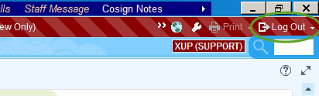

TAMPA GENERAL
- For help with Computer related issues at TGH sites, i.e. Passwords, Epic, Epic Training, etc.,
  - https://myaccess.tgh.org/ (For password resets ONLY)
  - https://helpdesk.tgh.org/ (Help Desk Self-Service site, ONLY accessible off TGH devices)
  - https://mindlab.tgh.org (MindLab for online Epic training access)
  - contact the Technology Support Center (Help Desk): 813-844-7490

MOFFITT CANCER CENTER

- For help with Computer and EMR (Cerner) issues at Moffitt Cancer Center:
  - Password Re-set
  - Account Issues
  - Mobile Access
You MUST CALL the MCC IT HELP DESK at (813) 745-4357 and ask to have a Ticket put in and that it be directed to Christine Hanna.

JAHVA

On July 1st, for issues with: | Contact:
PIV Exemptions/Intellispace Access  (Request a 14 day temporary PIV exemption for immediate use plus permanent exemption for Intellispace) | National IT Help Desk/Region 3  813.972.2000, ext. 6108
Computer Access | OI& T Office (ground floor)  Office: GB-020c
CPRS (EMR) Assistance  Consult Menu Access | Clinical Informatics, ext. 4292
Medication/Prescribing Access Issues | Pharmacy  Linda: 5am-1:30pm  Nigara: 7:30am-4pm  ext. 5804/833.9784
To Link PIV card to CPRS:  -Everyone must do when they log into CPRS | - CPRS Tools Menu  - Click “Digital Signing Setup”  - Click “Yes”  - Put Smart Card in the reader, then press “ok”  - Enter 6 digit PIV PIN #
No Access to PICIS – ICU/PCU Flowsheets | Contact House Staff Coordinator as follows:  Medicine: Victoria Anduze, ext. 6232  Surgery: Sonia Rivera, ext. 1727  Psychiatry: Tina Bianco, 813-631-2548  Radiology: Kevin Miller, ext. 5793  Neurology: Lidia Dordevic, ext. 7085  Ophthalmology: Deb Goode, ext. 7513  PMRS/SCI: Laura Manore, ext. 7688  PLMS: Ricardo Moven, ext. 2139  - Will need ePAS revision and Nursing Informatics notification.
Parking | Park on 3rd floor of garage with PIV card, or park anywhere on 5th or 6th floor if you do not have a PIV card.

