Pre-Cesarean Huddle Form



**The intent of this form/huddle is to define criteria for arrest of dilatation, failed induction and interventions for NRFHT’s as defined by the FPQC. It is also meant to explore safe options to prevent cesarean sections in an interdisciplinary setting on the OB unit.**

Huddle should occur when a c/s is being considered due to arrest, failed IOL or NRFHT’s. Huddles can occur for other reasons as deemed necessary by the providing team.

* **Date and time of huddle-** _________________________________________________________
* **G’s and P’s and Gestational age-** ___________________________**Current room**_____________
* **ROM time__________________________________ Last Cervical Exam____________________**
* **Attendees- list names**

Attending physician*required_____________________________________________________

Safety Nurse &/or Charge Nurse* 1 required__________________________________________

Bedside provider (CNM/Resident) *1 required ________________________________________

Primary RN (if available) __________________________________________________________

Anesthesia (if available) __________________________________________________________

* **Reason for huddle- (circle all that apply)**

C/S being considered NRFHT Arrest of Dilatation/Labor Dystocia Maternal Condition Failed IOL Other_______________________________________________________________________

* **FHT agreed upon interpretation *at the time of huddle*-** Baseline___________ Variability___________

Decels present (circle all that apply) - Early Variable Late Prolonged

Accels present- Yes / No Category of tracing- 1 2 3

* **Interventions done thus far (circle all that apply)** - *Reposition *IVF bolus for hypotension *O2 *Terbutaline

*Decrease Pitocin *Stop Pitocin *Amnioinfusion for variable decels *Remove Cervidil

*Remove balloon/Cook *Vaginal exam/VAS to elicit fetal response for minimal variability

* **Birth Outcome:** __________________________________________________________________________________

See back of page for Labor Dystocia, Failed IOL and Management of FHR Algorithm.

* **Labor Dystocia criteria-**
  + Less than 6cm – not in labor, does not meet these criteria (cannot call c/s due to Arrest if less than 6 cm, active labor has not been achieved, consider giving more time)
  + 6 cm - 9.5 cm dilated- was there at least 4 hours with adequate uterine activity or at least 6 hours with inadequate uterine activity and with oxytocin? If no, does not meet criteria for arrest- consider giving more time.
  + If 10cm- Primigravida- was there at least 3 hours or more in second stage- 4 hours with an epidural? If not, does not meet criteria for arrest, consider giving more time. Multiparous- was there at least 2 hours or more in the second stage (without an epidural)?
* **Failed IOL Criteria** –
  + If <6cm dilated, were there at least 12 hours of oxytocin after rupture of membranes?
  + If 6-10cm dilated, was there at least 4h with adequate uterine activity or at least 6h with inadequate uterine activity and with oxytocin?
  + If completely dilated, was there 3h or more of active pushing (4h with epidural)?

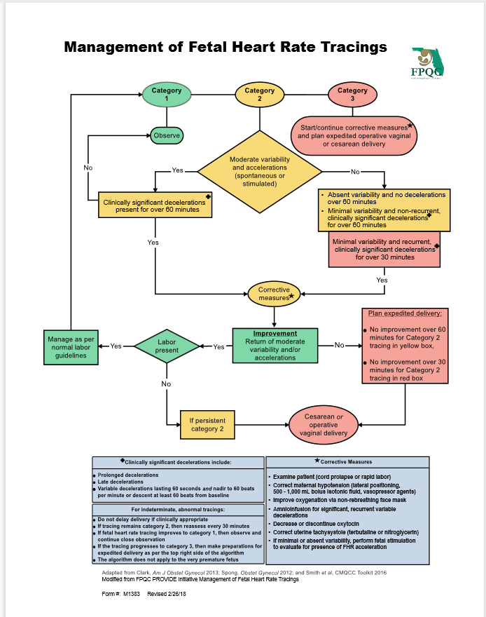

Reference:

Spong, C.Y., Berghella, V., Wenstrom, K.D., Mercer, B.M., and Saade, G.R. Preventing the First Cesarean Delivery: Summary of a Joint Eunice Kennedy Shriver National Institute of Child Health and Human Development, Society for Maternal-Fetal Medicine, and American College of Obstetricians and Gynecologists Workshop. Obstet Gynecol. 2012 November; 120 (5): 1181-1193.