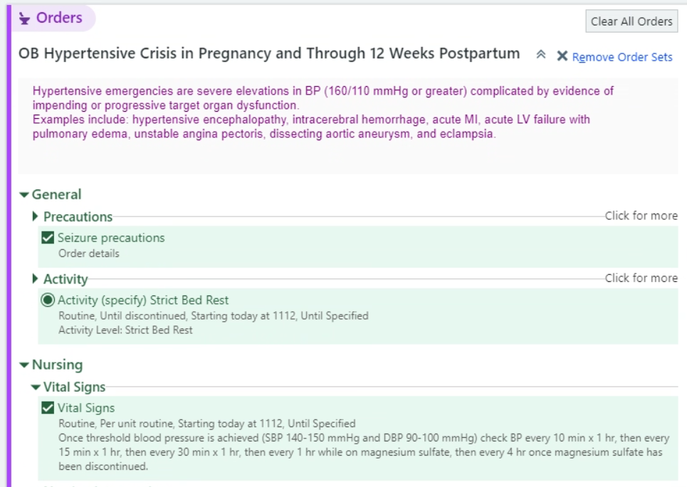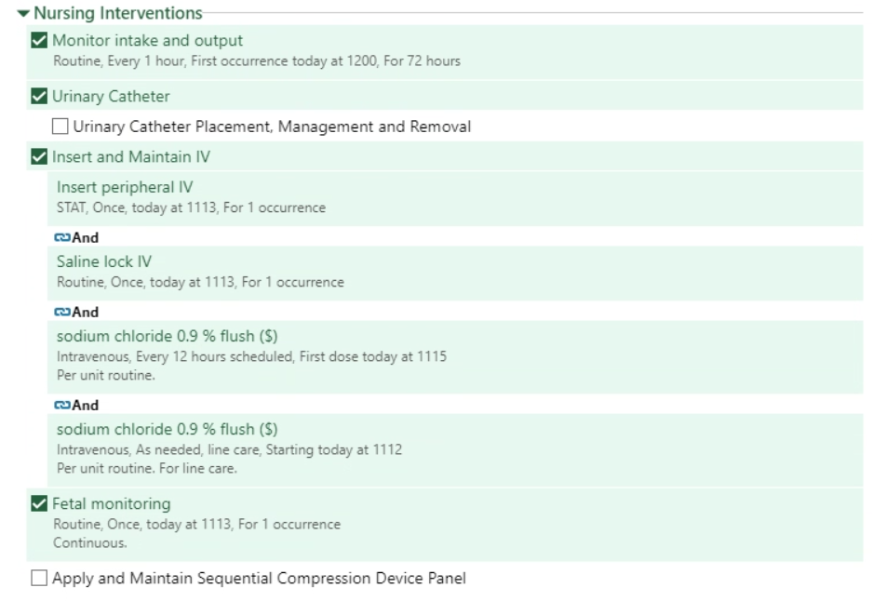

OB HTN Medications expand to either Regimen 1, 2, or 3:

Magnesium expands to this:

