Kangaroo Care for Infants on HFOV

Purpose
To instruct staff on positioning and management of the infant and kangaroo care (KC) person during skin-to-skin care to:
- Promote stable heart rate, respiratory rate, temperature, and oxygen saturation
- Increase time spent in quiet sleep and improve energy conservation
- Improve lactation outcomes and improve milk production
- Reduce infant and parent stress
- Positively impact infant brain development
- Enhance parental attachment and confidence in caring for their infant

Procedure
- Obtain Omni bed and a swivel adapter to ensure infant remains connected to ventilator at all times.

- Obtain RT (airway, circuit holder) RN (patient holder) and additional RT/Clinician to facilitate equipment maneuvering. In total: three caregivers.

- Ensure ETT securement device is optimized.

- Pre-position parent to side of isolette/ventilator in recliner/bed:
  - Position of chair is crucial to success of transition
  - Caregiver supporting airway/oscillator tubing shall be lead communicator of transition

- Lift top of Omni Bed.

- Move HFOV forward to allow for additional circuit slack.

- RT and RN position patient to face direction of parent (sidelying).

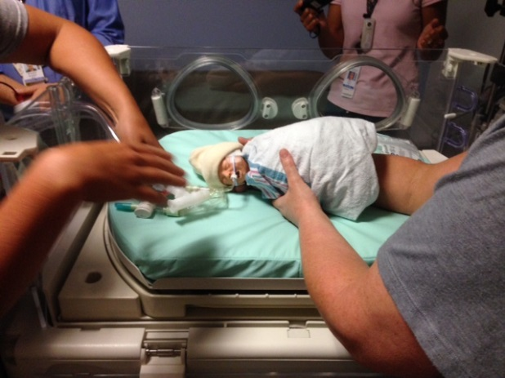
- Gently lift circuit up through giraffe and move patient to parent’s chest.

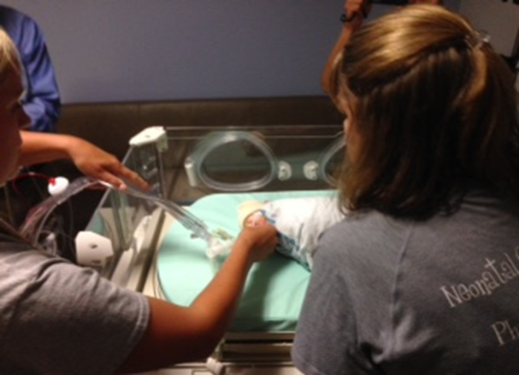

- Additional staff member to assist moving HFOV device as needed.

- Secure airway/tubing to parent.

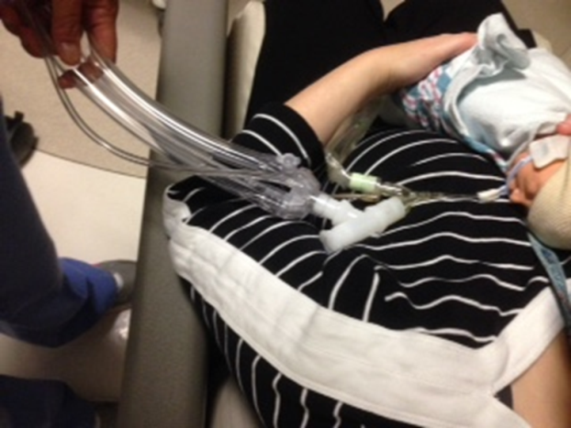

- If patient is utilizing a TCM, it may be unplugged and run on battery for additional patient monitoring during KC.

