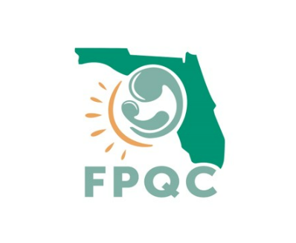
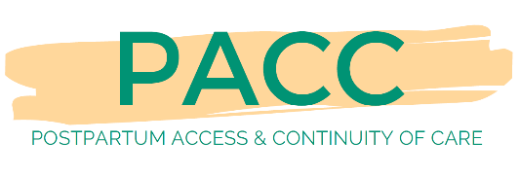
PACC Pledge

WE PROMISE TO PROVIDE RESPECTFUL POSTPARTUM (PP) PATIENT CARE TO ALL. Therefore, we will:

- Actively listen to each patient, ensuring their voice and message is heard regarding their safe PP transition to home and needed after care.

- Treat all patients in a respectful way that honors the patients’ beliefs and practices that may be different than our own.

- Actively engage all patients in all PP plans and decision making.

- Encourage our patients to ask questions and raise concerns about their PP care & conditions.

- Provide high-quality, evidence-based PP education with a focus on PP warning signs, the need for an early post birth safety check, and to seek attention early.

- Complete all PP care appointments and referrals prior to discharge.

- Welcome the patient’s chosen support persons to be present during PP discharge education and discussions.

- Ensure respectful care to all patients in PP policies & practices.

Signature: Date:

9.15.22

