Patient Information Sheet
Immediate Postpartum Implant

What is the Immediate Postpartum Implant?
The implant is a birth control option for women who have given birth. You can get the hormonal implant after delivery in the hospital. This is called immediate postpartum implant. A doctor or Certified Nurse-Midwife will insert the implant into your arm.
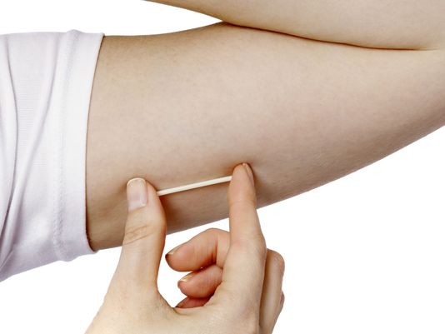
Why should I get the implant after delivery in the hospital?
- You can get pregnant right away after giving birth
- You have time to heal before getting pregnant again
- It’s convenient and you don’t have to schedule a separate appointment
- It works for years after being inserted
- It works better than all other birth control methods: pills, ring, patch, shot, condoms, and even sterilization

What else should I know about the implant?

- You can still breastfeed while using it
- It does not stop the spread of sexually transmitted diseases (STD’s); use condoms to prevent STD’s
- You may have irregular bleeding or your cycle may change

Where can I get more information?

- Talk to your health care provider
- Baby/birth spacing: http://www.healthyicc.org/your-health/baby-spacing
- Implant: http://www.arhp.org/Publications-and-Resources/Patient-Resources/fact-sheets/single-rod

Resources:
Florida Perinatal Quality Collaboration
USF Health – College of Public Health

12/5/18

