PDSA/DMAIC WORKSHEET

Cycle: 1 Start date for cycle: 6/1/2018 End date for cycle: 6/30/18

Project SMART aim: By 12/2019, FPQC participating hospitals will increase the percentage of LARC placement (IUD or implant) in postpartum women desiring LARC contraception from 0% to 50%.

Objective of this cycle (What are we trying to accomplish?):
Complete educate for >90% of nursing staff, residents, and attendings who deliver care to patients in Labor/Delivery and postpartum

What key driver does this change impact?
Trained clinicians are available to provide immediate postpartum LARC insertion

PLAN OR DEFINE-MEASURE-ANALZYE
What changes can we make that will lead to improvement?
Describe changes we plan to test
- Alyssa has prepared a PowerPoint presentation to review importance of immediate postpartum LARC insertion, contraindications, process, and follow-up for LARC.
- Rachel met with stakeholder to outline workflow (process map – current state and future state)

Who are stakeholders for this cycle? nursing staff (OB, OR), residents, midwives, and attendings who deliver care to patients in Labor/Delivery and postpartum

Tasks needed to implement these changes (How will we make this change happen?)
Task | Who is responsible  Consider locations the changes will affect | Due date
Educate Nurses and staff (OB, OR) | Pat | 6/30/18
Educate medicine residents | Rachel | 6/30/18
Educate OB attendings | Alyssa | 6/30/18
Education midwives | Jessica | 6/30/18
Develop PowerPoint | Alyssa | 6/7/18
Develop TGH policy for LARC | Pat  Alyssa  Rachel | 6/15/18

Measures for this cycle (How will we know that a change is an improvement)
Consider: balancing measures, measures to determine whether the prediction succeeds and your goal is achieved, how data will be collected & who is responsible for collecting data. You may find it easier to cut and paste from your measurement grid.

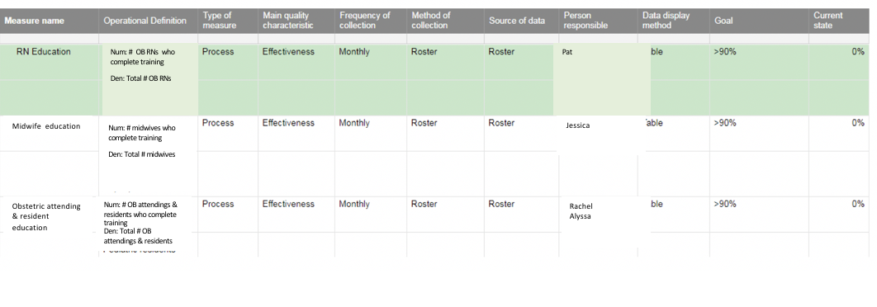
DO OR IMPROVE DEFINE-MEASURE-ANALZYE
What happened when the test was conducted?
Was the cycle carried out as planned (yes, no)? Yes

What did you observe (i.e., qualitative feedback from the team)?
- Education well received by nurses, residents, and pediatric attending.
- Midwives had difficulty attending sessions because covering for other providers to attend education
- Physicians were very receptive to involvement in defining workflow

What did you observe that was not part of the plan?
- Determining documentation around LARC placement and confirming consent
- Determining patient eligibility depending on insurance

STUDY OR CONTROL
Did the measured results and observations meet your objective?
Was your goal achieved (yes, no)? Yes
- Goal for education was achieved (RN: 95%, Attendings: 100%, Residents: 100%)

How do results of this test compare to previous performance? NA

If YES
- Do you plan to expand the test (yes, no)? Yes
Will you expand the scale (i.e., keep the same conditions, just test more)? We will include Maternal-Fetal-Medicine attendings and fellows. Continue regular trainings with staff yearly, to include new trainees and new hires
- Will you expand the scope (i.e., change the conditions)? No
- Will you expand the scale and scope (i.e., change locations/units and conditions)? No

If NO
- What data do you have to distinguish if your method of testing the change failed or if the designed change was not effective? NA

Were there any barriers with the cycles’ implementation (yes, no)? No
What else did you learn?
- It took time and lots of discussion to determine specifics on the policy before consensus could be achieved.
ACT OR CONTROL
Decide to Abandon, Adapt, or Adopt?

 | ABANDON: Discard change idea testing. Describe what you will change.
x | ADAPT: Improve the change & continue a larger scale. Develop an implementation plan for sustainability.
 | ADOPT: Select changes to implement on & try a new one

