**Breastfeeding Support: Nipple Shield Guidelines**

1. Purpose

To provide guidelines for the use of nipple shields with infants at Tampa General Hospital. All infants requiring nipple shields should have a lactation consult and

Nipple shields can facilitate attachment of the infant to the breast in the following conditions:

1. Preterm infants who constantly slip off the breast, preterm infants that fall asleep as soon as they are attached and are unable to maintain regular nutritive sucking.
2. Flat or inverted nipples with repeated failure to achieve attachment with an alert infant.
3. To protect damaged nipples while healing (last resort before mom giving up).
4. All infants requiring a nipple shield should have lactation consult. Rarely are nipple shields appropriate in the first 24 hours of attempting breastfeeding.

**PROCEDURE**

1. Ensure mother has an adequate milk supply.
2. Ensure mother is aware of, and agrees to the use of a nipple shield. Shields may be used by patient after instruction by IBCLC, IBCLC candidate or staff nurse with documented competency.
3. Choose appropriate size shield for the infant’s mouth. Sizes in Pyxis include 20 and 24 mm.
4. To fit shield, ask the mother to express a few drops of milk into the shield and around the areola. The shield should be applied centrally over the nipple, the cut out area being placed where the infant’s nose will be positioned. (See Figure 1.)
5. Stretch the shield to allow the nipple to be drawn in. Instruct patient to stretch teat portion of nipple shield to create suction and draw as much of the nipple-areolar complex into the opening.
6. Another technique to draw patient’s nipple into shield is to flip shield almost inside out before applying. When shield moves back into position, gentle traction is exerted on nipple-areolar complex.
7. Assess for proper latch (see Figure 2.) effective suckle and audible swallowing, which indicate proper milk transfer and use of test weight to verify volume of milk transferred may be indicated.
8. Document indication for use and its effectiveness in the infant’s EMR (LATCH score) review daily the need to continue.
9. The nipple shield should be washed in hot soapy water, rinsed and dried after each use and stored in a clean container under the infant’s crib/ drawer.
10. Regard use of the nipple shield as a temporary measure. Patient and staff should develop a plan to wean infant from shield as soon as is appropriate. Assure Lactation consult has been completed.
11. ***If nipple shields are used at discharge ensure appropriate follow–up is arranged eg. Preterm infants will require the nipple shield until they are able to maintain attachment for adequate milk transfer for the whole feed. This may be until approximately term corrected age or longer.***

**Figure 1.**

* Nipple should pull into shield
* Positive signs baby is transferring- milk or colostrum in shield

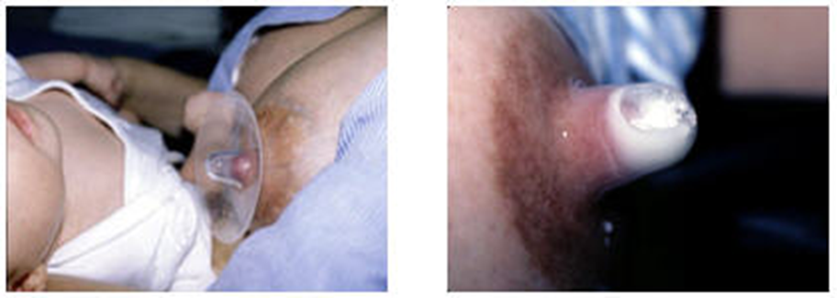

**Figure 2.**

Good Latch with shield Bad latch with shield

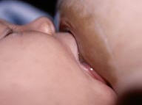 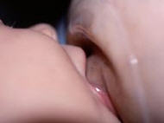

**References :**

Meier PP, Brown LP, Hurst NM, et al. Nipple shields for preterm infants: effect on

milk transfer and duration of breastfeeding. J Hum Lact 2000;16:106-113.

Genna, C. W. (2009). Selecting and using breastfeeding tools. Amarillo: Hale.

Clay, B. W. (2012). Medela. Retrieved September 6, 2012, from Nipple Shields: http://www.medelabreastfeedingus.com/tips-and-solutions/112/nipple-shields