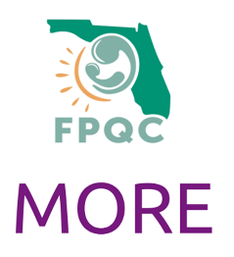
Additional Resources

Billing Medicaid for SBIRT:
  - https://ahca.myflorida.com/Medicaid/statewide_mc/pdf/2018-23_plan_comm/PT_2021-18_SBIRT.Procedure.Codes.Added.Effective.Jan.1.2021_05.24.2021.pdf
CME training for SBIRT:
  - https://cme.ufl.edu/screening-brief-intervention-and-referral-to-treatment-sbirt-for-pregnant-women-and-other-adult-patients/
Medicaid Managed Care Plan OUD Contacts:
  - https://ahca.myflorida.com/Medicaid/Policy_and_Quality/Policy/health_plan_resources.shtml
Buprenorphine Training for OB Providers: Buprenorphine Training for Providers
MORE Video Series: MOREvideos | USF Health

