When an OB patient screens + for Opioid Use Disorder (OUD) during an admission (L&D/Antepartum/MBU),
a MORE Folder is obtained by the patient’s nurse. Folder contents are listed below:
(1) MORE Checklist (Place on chart, update PRN, & review at each care handoff)
(2) MORE Provider education materials: Save a Life Naloxone (Narcan®) guide to help providers complete Naloxone
counseling/prescription, SBIRT Pocket Card, MORE OUD Algorithm
(3) MORE patient education materials: MORE HOPE pamphlet, Naloxone tri-fold, contraception information
- Nursing works with the rest of the OB clinical team to make sure the MORE Checklist is completed prior to discharge.
- Since OUD is the leading cause of maternal death in Florida, all members of the health should work to reduce stigma, treat patients with empathy & compassion, & follow this checklist to help improve outcomes.
Maternal Opioid Recovery Effort (MORE) Care and Discharge Checklist

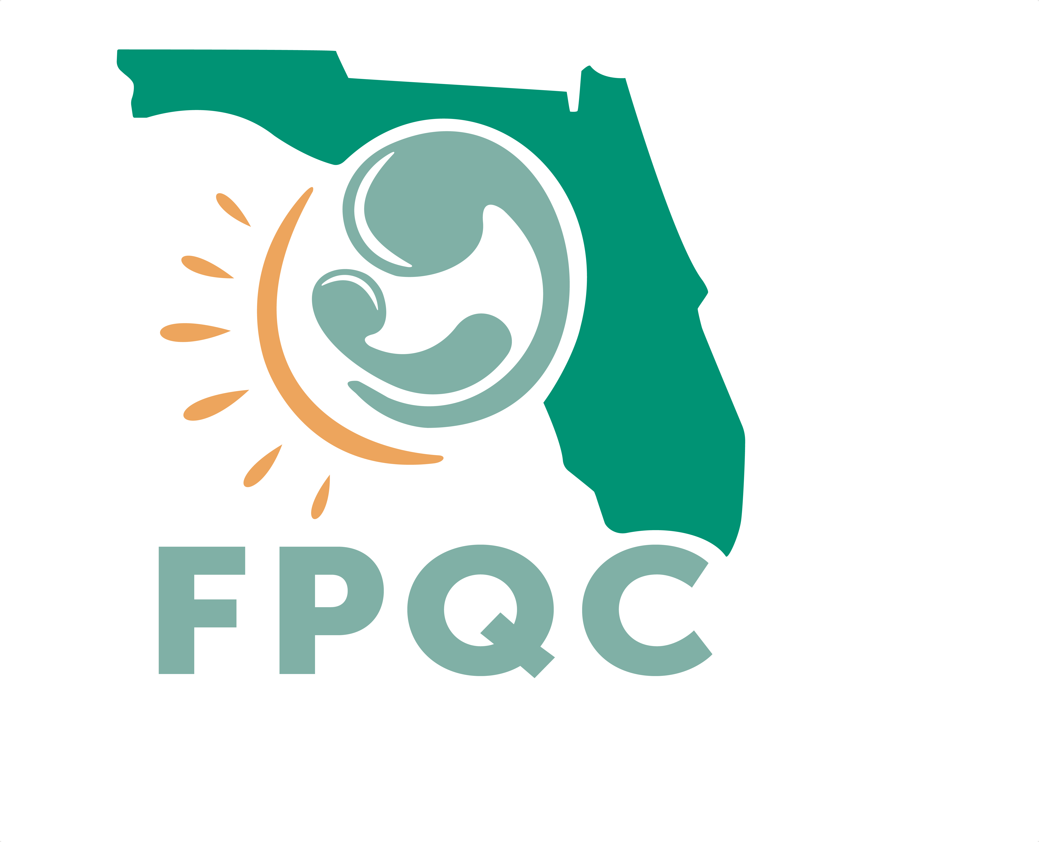

Clinical Team Initials/Notes/Date

Care Checklist

Report + OUD screen to OB provider & give provider the MORE Clinical Algorithm to review
Report + OUD screen to Pedi/Neo when baby is born
Team Huddle during hospitalization: OB Provider, Neo/Peds, Social Work, Charge & Bedside RN
Confirm Hep C, Hep B, HIV, & other recommended secondary screening completed
Domestic Violence screening & Mental Health screening completed
Confirm the provider has the “Save a Life Naloxone” guide to assist with Naloxone counseling/
prescription as a risk reduction strategy for all patients who use opioids regularly
Hand off/Review MORE folder & MORE Checklist with postpartum RN
Clinical Team Initials/Notes/Date

Prior to Discharge

Review MORE patient education materials (MORE folder or http://fpqc.org/more)
Reinforce important role of mom/family in self-care & care of baby with NAS.
Request a Neo/Peds consult for positive OUD screen to counsel on NAS & how moms engage in opioid exposed newborn care when appropriate
Confirm patient’s readiness for Medication-Assisted Treatment (MAT) & plan is documented. Free assistance with clinical management of OUD/MAT is available for providers through Florida BH Impact: 833-951-0296
Confirm Social Work/Case Management Consult is done.
Confirm patient is linked to behavioral health services/recovery treatment program & has follow up or work through social work consult to confirm a warm handoff & close follow up to establish linkage to services.
Work with Neo/Peds team to engage & support mom/family, providing non-pharmacologic care as appropriate: breastfeeding, skin-to-skin, rooming-in, Eat Sleep Console (ESC).
Confirm Behavioral Health and/or MAT appointment made before discharge.
Confirm Naloxone (Narcan ®) counseling has been provided & prescription has been provided before discharge. If possible, have the prescription filled prior to discharge.
Confirm all recommended secondary infectious disease screening completed, results provided to the patient, & follow-up plan established by OB for all positive screens.
Confirm comprehensive contraception counseling has been provided & method of contraception has been identified/prescribed.
Confirm patient has early postpartum follow-up appointment with OB for 1-2 weeks PP scheduled.
Ensure the OB clinical team is in communication with Neo/Peds to confirm a coordinated Plan of Safe Care (POSC). Make sure the patient/family understands their POSC.
Ensure Alternatives to Opioids pamphlet has been provided if opioids prescribed.
Review this Checklist with OB Provider. Determine next steps for ANY incomplete elements.
Florida Perinatal Quality Collaborative 2/11/21 Adapted from ILPQC-MNO Initiative

