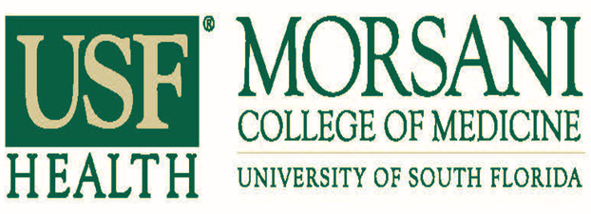
Division of Digestive Diseases & Nutrition Faculty – Affiliate Sites
VA Faculty

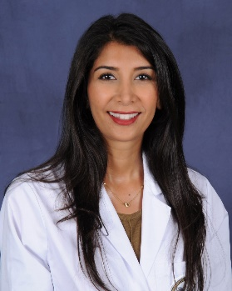
Roshanak Rabbanifard, MD
Title: Associate Program Director, USF GI Fellowship
Assistant Professor of Medicine USF Morsani School of Medicine
Gastroenterologist, James A. Haley Veterans Hospital
Medical School: USF Health Morsani College of Medicine
Residency: USF Morsani College of Medicine, Internal Medicine
Fellowship: USF Morsani College of Medicine
EMAIL: roshanak.rabbanifard@va.gov

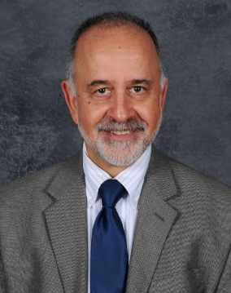
Donald Amodeo, MD
Title: Assistant Professor of Medicine USF Morsani School of Medicine
Gastroenterologist, James A. Haley Veterans Hospital
Medical School: SUNY at Buffalo, School of Medicine
Residency: SUNY at Buffalo, School of Medicine
Fellowship: SUNY at Buffalo, School of Medicine
EMAIL: donald.amodeo@va.gov

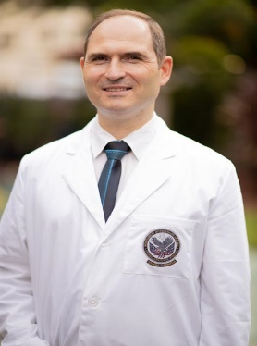
Wojciech Blonski, MD, PhD
Title: Assistant Professor of Medicine USF Morsani College of Medicine; Gastroenterologist, James A Haley Veteran’s Hospital
Medical School: Wroclaw Medical University
Residency: United Health Services Hospital Program
Fellowship: University of South Florida Morsani College of Medicine
EMAIL: wojciech.blonski@va.gov

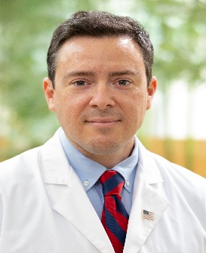
Jason Colizzo, MD
Title: Assistant Professor of Medicine USF Morsani College of Medicine
Gastroenterologist, James A Haley Veteran’s Hospital
Medical School: Florida State University
Residency: University of South Florida Morsani College of Medicine
Fellowship: University of South Florida Morsani College of Medicine
EMAIL: jason.colizzo@va.gov

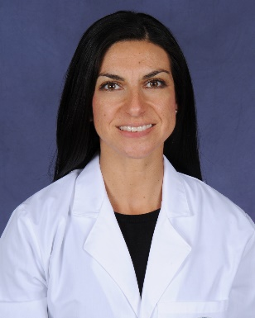
Carla Duffoo, DO
Title: Staff Attending James A Haley Veteran’s Hospital
Medical School: Nova Southeastern University Osteopathic Medicine
Residency: University of Miami/Jackson Memorial Hospital
Fellowship: Cleveland Clinic
EMAIL: carla.duffoo@va.gov

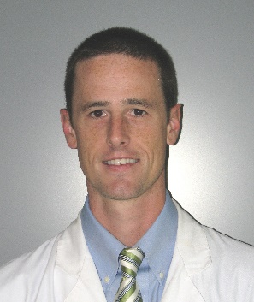
Jeffrey Gill, MD
Title: Associate Professor of Medicine USF Morsani College of Medicine
Director of Endoscopy, James A Haley Veterans’ Hospital
Medical School: University of Maryland School of Medicine
Residency: University of Florida
Fellowship: University of South Florida Morsani College of Medicine
EMAIL: jeffrey.gill@va.gov

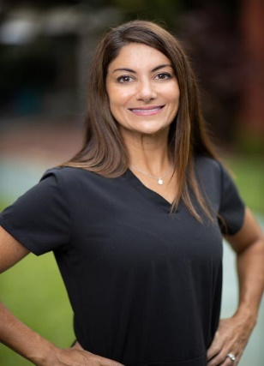
Susan Goldsmith, MD
Title: Assistant Professor, USF Morsani College of Medicine;
Staff Attending James A Haley Veteran’s Hospital
Medical School: The Chicago Medical S chool
Residency: Lenox Hill Hospital, NY
Fellowship: Lenox Hill Hospital, NY
EMAIL: susan.goldsmith@va.gov

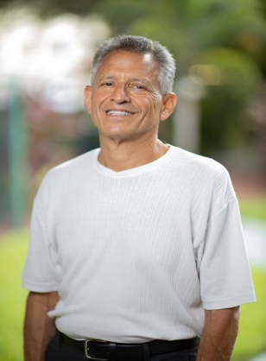
Robert Hadesman, MD
Title: Staff Attending James A. Haley Veterans’ Hospital
Medical School: Washington University
Residency: Northwestern University
Fellowship: Mayo Clinic Rochester, MN
EMAIL: robert.hadesman@va.gov

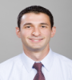
Jonathan Keshishian, MD
Title: Staff Attending James A Haley Veteran’s Hospital
Medical School: USF Health Morsani College of Medicine
Residency: USF Health Morsani College of Medicine, Internal Medicine
Fellowship: USF Morsani College of Medicine; Division of Digestive Diseases and Nutrition
EMAIL: jonathan.keshishian@va.gov

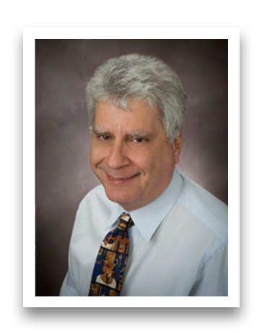
Dennis Laffer, MD
Title: Director, Gastrointestinal Medical Clinic, James A Haley Veteran’s Hospital
Medical School: University of Michigan School of Medicine
Residency: William Beaumont Hospital
Fellowship: Cleveland Clinic
EMAIL: dennis.laffer@va.gov

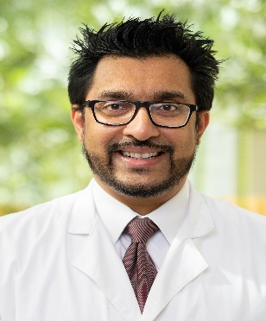
Brijesh Patel, MD
Title: Gastroenterologist, James A. Haley Veteran’s Hospital
Medical School: University of Alabama
Residency: University of South Florida Morsani College of Medicine
Fellowship: University of South Florida Morsani College of Medicine
Advanced Fellowship: Vanderbilt – Advanced Endoscopy Fellowship
EMAIL: brijesh.patel@va.org

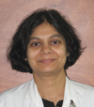
Gitanjali Vidyarthi, MD
Title: Associate Professor of Medicine USF Morsani College of Medicine; Staff Attending, James A Haley Veteran’s Hospital
Medical School: MGM Medical College and Patna Medical College and Hospital
Residency: Prince George’s Hospital Center
Fellowship: North Shore University Hospital
EMAIL: gitanjali.vidyarthi@va.gov

Moffitt Cancer Center Faculty

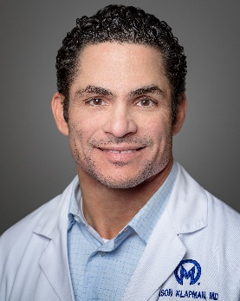
Jason Klapman, MD, FASGE
Title: Director of Endoscopy
Medical School: Finch University of Health Sciences/The Chicago Medical School – MD
Residency: Rush Presbyterian St. Luke's Medical Center
Fellowship: University Chicago Hospital- Gastroenterology
Advanced Fellowship: University of California at Irvine Medical Center, Orange, CA - Interventional Endoscopy
EMAIL: jason.klapman@moffitt.org
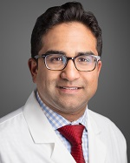
Aamir N. Dam, MD
Title: Director, Advanced Endoscopy Fellowship
Medical School: Boston University School of Medicine - MD
Residency: Boston University School of Medicine - Internal Medicine
Fellowship: Albany Medical Center - Gastroenterology
Advanced Fellowship: Carolinas Medical Center - Advanced Endoscopy
EMAIL: aamir.dam@moffitt.org

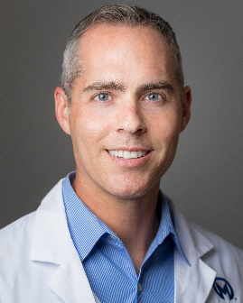
Mark S. Friedman, MD
Medical School: SUNY Downstate Medical Center - MD
Residency: George Washington University Medical Center
Fellowship: Albany Medical College – Gastroenterology
EMAIL: mark.friedman@moffitt.org

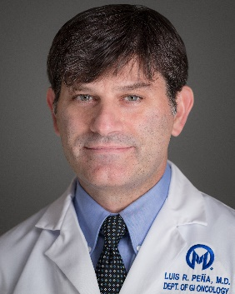
Luis R. Peña, MD, FACG, AGAF
Medical School: Francisco Marrouquin University - MD
Residency: University of Kentucky - Internal Medicine
Fellowship: University of Kentucky – Gastroenterology
EMAIL: luis.pena@moffitt.org

TGH Hepatology Faculty

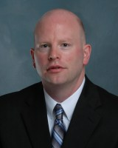
Christopher Albers, MD
Title: Director, Hepatology Fellowship
Medical School: University of Cincinnati College of Medicine
Residency: University of Cincinnati College of Medicine
Fellowship: University of Cincinnati College of Medicine
EMAIL: calbers@tgmg.org

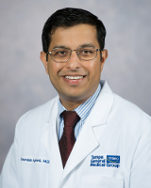
Saurabh Agrawal, MD
Medical School: Federal University of Paraiba School of Medicine (Campina Grande, Brazil)
Residency: Cleveland Clinic, Internal Medicine
Fellowship: Indiana University School of Medicine, Gastroenterology and Hepatology
Carolinas Medical Center, University of North Carolina, Transplant Hepatology
Massachusetts General Hospital, Harvard Medical School, Clinical and Basic Science Research, Hepatology
EMAIL: sagrawal@tgmg.org

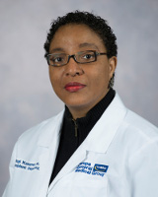
Nyingi Kemmer, MD, MPH, MSc
Medical School: University of Sokoto (Sokoto, Nigeria)
Residency: Cook County Hospital
Fellowship: University of Texas Medical Branch
Scripps Clinic and Research Foundation
EMAIL: nkemmer@tgmg.org

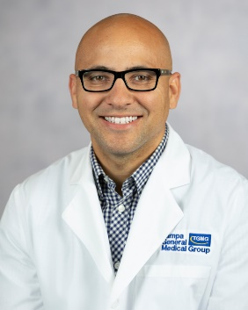
Miguel Malespin, MD
Medical School: Ponce Health Sciences University
Residency: University of Illinois
Fellowship: University of Illinois, Gastroenterology
Loyola University Medical Center, Transplant Hepatology
EMAIL: mmalespin@tgmg.org

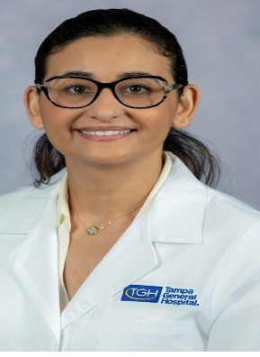
Kawtar Al Khalloufi, MD
Medical School: Université Hassan II, faculté de médecine et de pharmacie ( Casablanca, Morroco)
Residency: Howard University Hospital
Fellowship: GI Fellowship: Howard University Hospital; Transplant Hepatology Fellowship: Johns Hopkins Hospital
EMAIL: kalkhalloufi@tgmg.org

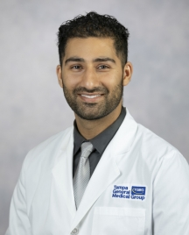
Rashid Syed, MD
Medical School: Aga Khan University Medical College, (Karachi, Pakistan)
Residency: Westchester Medical Center
Fellowship: University of South Florida, Hepatology and Transplant Hepatology fellowship Oschsner Medical Center, Gastroenterology
EMAIL: rsyed@tgmg.org

