UNIVERSITY OF SOUTH FLORIDA
PLASTIC & RECONSTRUCTIVE SURGERY RESIDENCY PROGRAM
SCOPE OF PRACTICE
Revised August 2018

PROGRAM DIRECTOR: MICHAEL A. HARRINGTON, M.D., M.P.H.
ASSOCIATE PROGRAM DIRECTOR: WYATT G. PAYNE, M.D.

This document pertains to the USF Plastic Surgery Rotations at Tampa General Hospital, the Moffitt Cancer Center, Bay Pines Veterans Hospital, James A. Haley Veterans Hospital, All Children’s Hospital, Florida Orthopedic Institute, and Private Physician Offices. These rotations make up the resident training program in Plastic and Reconstructive Surgery at the University of South Florida. All ACGME and Joint Commission guidelines pertaining to graduate medical education apply to this rotation.
In keeping with ACGME and Joint Commission guidelines, the faculty and program director are responsible for providing all residents with direct experience in progressive responsibility for patient management. All patient care at the aforementioned hospitals provided by our USFPS residents will be provided under direct or indirect faculty supervision. Supervision must be documented in the medical record in accordance with Plastic and Reconstructive Surgery at the University of South Florida compliance guidelines.
Faculty and residents are educated to recognize fatigue and sleep deprivation and must adopt and apply policies to prevent and counteract its potential and negative effects on patient care and learning.
Scope of Practice is defined as “authorized care” of the procedures, actions, and processes that are permitted for the licensed individual. The scope of practice is limited to that which the individual has received education and experience, and in which he/she has demonstrated competency.
Activities performed without direct supervision require access to the supervisory physician for communication and physical access within 30 minutes. Activities performed with direct supervision require presence of the supervisory physician. Residents are authorized to perform any activity assigned while under direct supervision. Plastic Surgery residents can evaluate outpatients, write prescriptions, write orders and progress notes, and otherwise complete medical records. Residents cannot perform invasive procedures (chest tube, arterial line, central line, and endotrachael intubation) without direct supervision until they have completed an ACLS course. Plastic Surgery residents cannot function without direct supervision by an attending physician who has privileges for patient care and to perform the indicated procedures. Final interpretation of all diagnostic and therapeutic studies requires direct supervision. Residents at each postgraduate year of training, while not limited to the following activities, are specifically allowed to do these without direct supervision. This document will be modified by the program director based on additions to the training program.

General Core Competencies Expected for Plastic Surgery Residents
Patient Care:
- Gather accurate and essential information about the patient using the following clinical skills: medical interviewing, physical examination, and diagnostic studies.
- Make informed diagnostic and therapeutic decisions based on patient information, current scientific evidence, and clinical judgment with review by the attending physician.
- Use consultants and referrals appropriately with review by the attending physician.
- Develop and carry out patient care management plans with review by the attending physician.
- Prescribe and perform competently all medical procedures considered essential for the scope of practice with the level of supervision as determined by the attending physician.
- Counsel patients and families in order to provide their care through the provision of information necessary to understand illness and treatment, share decisions, and obtain informed consent with review by the attending physician.
- Prioritize and delegate multiple tasks to deliver patient care efficiently with review by the attending physician.
- May assist in surgery and perform certain operations at the discretion of the attending physician.
- Can write orders for restraints. Can perform minor procedures including suturing lacerations under indirect supervision once a minimum number of ten (10) procedures have been directly supervised.

Medical Knowledge:
- Use of current medical information and scientific evidence for patient care.

Interpersonal Skills and Communication:
- Communicate effectively in a developmentally appropriate manner with patients and families to create and sustain a professional and therapeutic relationship across broad range of socioeconomic and cultural backgrounds.
- Communicate effectively with physicians, other health care professionals, and health related agencies.
- Work effectively as a leader of a health care team.
- Maintain comprehensive, timely, and legible medical records

Practice-based Learning and Improvement:
- Actively participate in the education of patients, families, students, and other health professionals with the level of supervision as determined by the attending physician.
- Acknowledge medical errors and mechanisms for prevention to supervising Attending physician, program director, and Risk Management at facility when occurs.

Professionalism:
- Demonstrate respect for and respond to the needs of patients
- Assure continuity of care is maintained by availability and appropriate transfer of information when going off duty.
- Demonstrate high standards of ethical behavior.

System-based Practice:
- Practice cost-effective health care and resource allocation that does not compromise quality of care.
- Advocate for quality patient care and assist patients in dealing with the system complexities.
- Work with health care mangers and health care providers to assess, coordinate, and improve patient care.

PGY Level Specific Expectations for Plastic Surgery Residents

PGY 1
  - WITHOUT Direct Supervision
- Can bring patients into operating room for induction of anesthesia
- Can insert IV lines, and Foley catheters
- Can write admission orders, pre and post-op orders and notes
- Can dictate admission history and physical, write progress notes, orders, and prescriptions
- Can dictate discharge summaries; can write orders for restraints.

PGY 1
  - WITH Direct Supervision
- May provide in-hospital care, assist in surgery, and perform certain operations.
- May place of arterial lines, central lines, chest tubes, Swan-Ganz catheters under the direct supervision of a senior (> PGY-3) resident or Attending.
- Can perform noninvasive Plastic Surgery procedures including CO2 Laser Therapy, Botox Injection, Filler Injection, etc

PGY 2
  - WITHOUT Direct Supervision
- Can participate in SICU activities
- Can function in the SICU under the direct supervision of the SICU attending in both the intensive care unit and non-intensive care unit.
  - This will allow placement of arterial lines, central lines, chest tubes, Swan-Ganz catheters, endotrachael and other superficial procedures.

PGY 2
  - WITH Direct Supervision
- Under supervision, may assist in surgery and perform certain operations at the discretion of the attending surgeon.
- Can perform noninvasive Plastic Surgery procedures including CO2 Laser Therapy, Botox Injection, Filler Injection, etc.

PGY 3
  - WITHOUT Direct Supervision
- Can function as senior resident on selected services under the direction of a chief resident and attending physician.
- Can initiate surgical procedures.
- Can administer conscious sedation and write orders for restraints.
- Can function as senior resident on call and as senior resident in the SICU.
- Can participate in clinics.
- Can evaluate trauma patients in the ER and supervise their resuscitation (ATLS certified).
- Can perform noninvasive Plastic Surgery procedures including CO2 Laser Therapy, Botox Injection, Filler Injection, etc. Must have logged 5 CO2 Laser Cases in PSOLs before can perform CO2 laser without direct supervision.

PGY 3
  - WITH Direct Supervision
- Under supervision, may assist in surgery and perform certain operations at the discretion of the attending surgeon.

PGY 4
  - WITHOUT Direct Supervision
- Can function as senior resident and supervise routine ward activities and SICU activities.
  - All aspects of diagnosis and care of disorders affecting the soft tissues of the body, including burns, pressure sores, and acute trauma.
- Can participate in clinics and supervise the conduct of outpatient clinics.
  - Diagnosis and management, both operative and non-operative, of plastic surgery patients, including breast reconstruction, cancer reconstruction, massive weight loss, and cosmetic patients.
- Can evaluate outpatients for emergency surgical procedures.
  - Diagnosis and management, both operative and non-operative, of acute soft tissue trauma of the entire body and bone trauma of the face.
- Can initiate surgical procedures after discussion with an appropriate attending physician who has privileges to perform the anticipated procedure and anticipating the arrival of the attending surgeon.
- Can administer conscious sedation and write orders for restraints.
- Can oversee medical record completion.
- Can perform noninvasive Plastic Surgery procedures including CO2 Laser Therapy, Botox Injection, Filler Injection, etc.

PGY 4
  - WITH Direct Supervision
- Under supervision, may assist in surgery and perform certain operations at the discretion of the attending surgeon.

PGY 5
  - WITHOUT Direct Supervision
- Can function as senior resident and supervise routine ward activities and SICU activities.
- Can participate in clinics and supervise the conduct of outpatient clinics.
- Can evaluate outpatients for emergency surgical procedures.
- Can initiate surgical procedures after discussion with an appropriate attending physician who has privileges to perform the anticipated procedure and anticipating the arrival of the attending surgeon.
- Can administer conscious sedation and write orders for restraints.
- Can oversee medical record completion.
- Can perform noninvasive Plastic Surgery procedures including CO2 Laser Therapy, Botox Injection, Filler Injection, etc.

PGY 5
  - WITH Direct Supervision
- Under supervision, may assist in surgery and perform certain operations at the discretion of the attending surgeon.

PGY 6
  - WITHOUT Direct Supervision
- Can function as senior resident and supervise routine ward activities and SICU activities.
- Can participate in clinics and supervise the conduct of outpatient clinics.
- Can evaluate outpatients for emergency surgical procedures.
- Can initiate surgical procedures after discussion with an appropriate attending physician who has privileges to perform the anticipated procedure and anticipating the arrival of the attending surgeon.
- Can administer conscious sedation and write orders for restraints.
- Can oversee medical record completion.
- Can perform noninvasive Plastic Surgery procedures including CO2 Laser Therapy, Botox Injection, Filler Injection, etc.

PGY 6
  - WITH Direct Supervision
- Under supervision, may assist in surgery and perform certain operations at the discretion of the attending surgeon.

Evaluation of Patients in the Emergency Room
PGY-1 residents must be directly supervised by a senior (>PGY-2) resident. PGY-2 residents may evaluate patients in the ER under the supervision of a senior (>PGY-3) resident. PGY-4/5/6 residents may evaluate patients in the ER under the supervision of the attending surgeon. If requested by the attending in the ER, the senior resident must consult with the attending surgeon on call prior to discharging a patient from the emergency room. The attending surgeon must also be informed about all patients admitted to his service from the ER.
Change in Patient Status
Attending physicians must be informed when a patient on his/her service has a clinically important change in status; this includes but is not limited to instability in vital signs, transfer to the intensive care unit, intubation, need for an invasive procedure/monitoring or death.
Faculty Responsibility for Supervision
Residents are directly supervised by the faculty on a day-to-day basis during all aspects of the rotation and at all sites during the entire program. Residents work directly with faculty to evaluate patients preoperatively, during operative procedures, and for postoperative assessment and follow-up. As the resident gains experience, he/she is given more responsibility under the supervision of the faculty member.
Specifically, pre-operatively the resident evaluates patients in the clinics at all facilities. The residents present the case to the faculty with recommendations for treatment, either operative or non-operative. Together a plan is formulated for each patient. In the operating room, the residents and faculty operate together. A senior resident may supervise a junior resident if it is a more straightforward case. If not, the senior resident will do the case to his/her appropriate level. All of this is done under the direct supervision of the faculty. Post-operative care is in the clinic. The resident is available for post-operative evaluation. Senior residents are expected to be responsible for the complete continuum of care for resident cosmetic cases. All of this is done under the direct supervision of the faculty.
All supervision is direct except at night. At night faculty are available at home or by beeper. Telephone consultation determines the treatment of emergency room patients. Faculty have access to x-rays at home and are opening a new portal at TGH for photo evaluation. All transfer patients are routed through the TGH Transfer Center and accepted only by faculty. A similar policy is true for both VA facilities. No patient goes to the operating room without direct faculty supervision.
See also policy on “Duty Hours”.
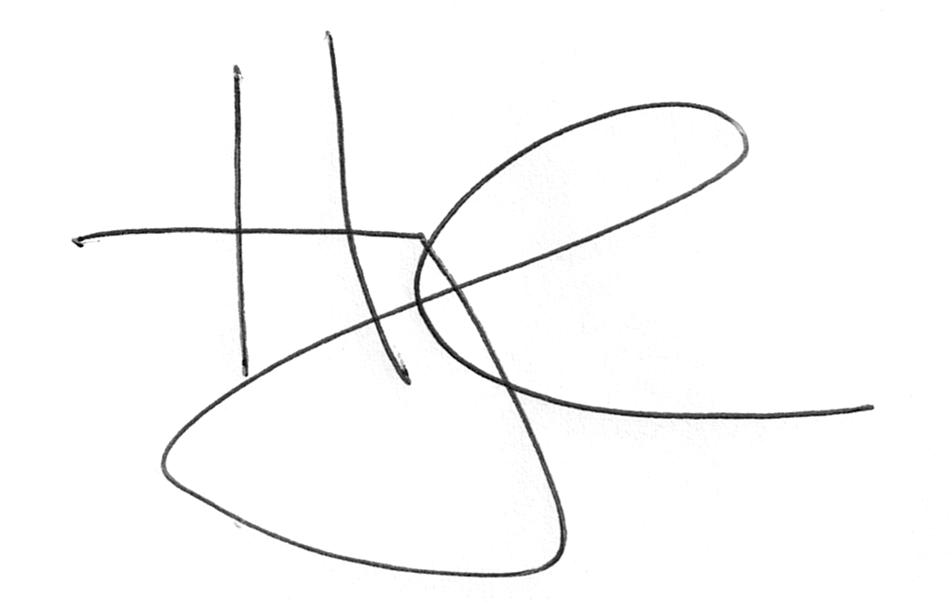
Michael A. Harrington, M.D., M.P.H.
Residency Program Director
Associate Professor of Surgery
Department of Plastic Surgery
University of South Florida

Reviewed: 8/24/2018

