Contact:  Catherine M. Lynch, M.D.  AOA Councilor, Gamma Florida Chapter  USF Morsani College of Medicine  Phone: (813) 974-1582 | 12901 Bruce B. Downs Blvd MDC2  Tampa, FL 33612 | 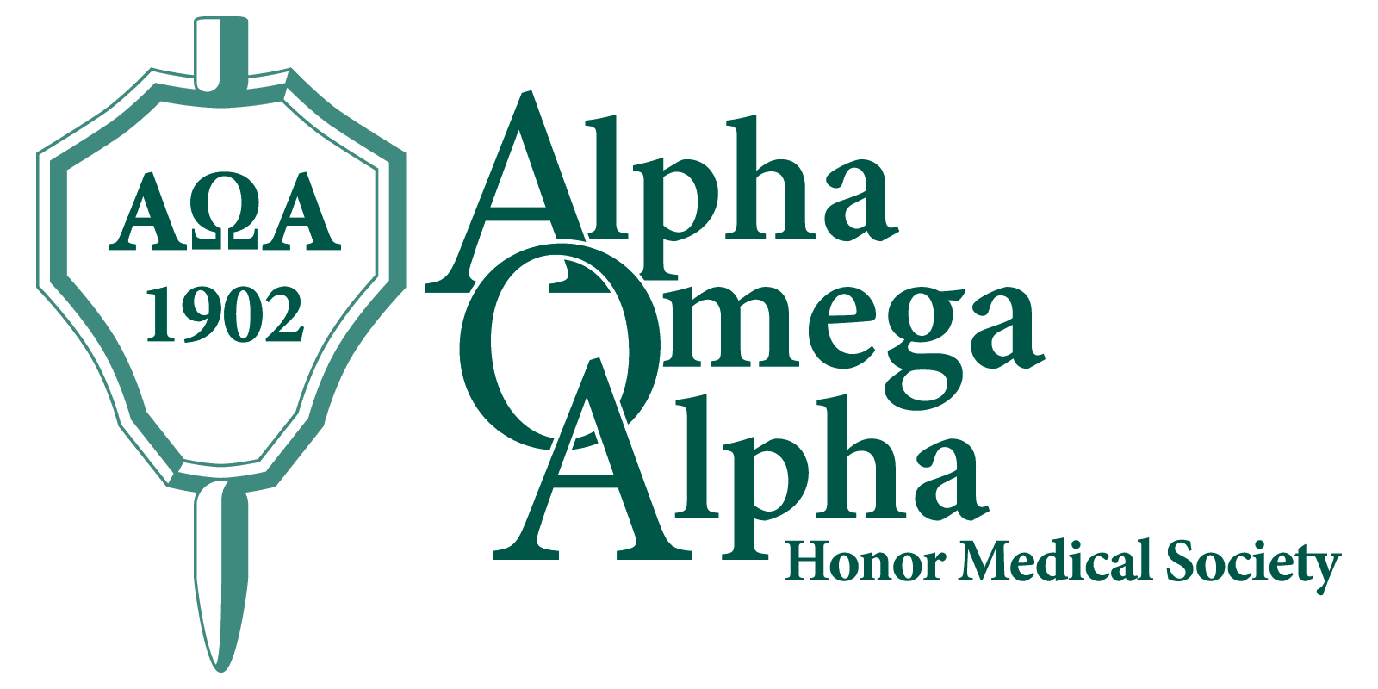

Press Release

USF Morsani Students, Alumni, Faculty, Residents Named to AOA Honor Medical Society
Tampa, October 5, 2015: Twenty-one USF Morsani College of Medicine (MCOM) Class of 2016 medical students were elected to the Alpha Omega Alpha (AOA) honor medical society in the 2015 fall election cycle. Twice a year, the AOA Gamma Chapter at USF MCOM elects new members, chosen from the top quartile of the class, based on criteria of academic performance, leadership, service, and professionalism. A total of one-sixth of the class may be chosen. The society’s motto is “Be worthy to serve the suffering.”
Membership in AOA is considered to be one of the highest academic honors a student can receive and is a distinction that accompanies a physician throughout his or her career.
Congratulations to the following 21 USF MCOM Class of 2016 students who will be formally inducted at the AOA Gamma Chapter annual spring banquet:
Mr. Jacob Blount (LHVN) | Mr. Nicholas Govsyeyev | Mr. Cameron Paterson (LHVN)
Ms. Alisha Bonaroti (LHVN) | Mr. Keith Groshans (LHVN) | Ms. Kathryn Rodriguez
Mr. Zachary Burden | Mr. Seth Grubb | Ms. Melissa Rosas
Ms. Alison K. Cullinane | Ms. Pamela Kim (LHVN) | Mr. Robert Casey Sullivan
Ms. Kathryn Grace Dean | Mr. Jake Luan | Mr. Mina Ehab Tadros
Mr. Viktor Flores | Mr. Casey Nagel | Ms. Miqi Wang
Ms. Chelsea Gorsline | Ms. Brianna Oliver | Mr. Jonathan W. Wischhusen

They will join their following Class of 2016 classmates who earned the prestigious honor of being elected as juniors:
Mr. John Derek DeNigris | Ms. Kathleen Pombier
Mr. Nick James (LVHN) | Ms. Elizabeth Nicole Teal*
Mr. Jonathan Koscso** | Mr. Matthew R. Thau (LVHN)
Ms. Taylor Martin | Mr. William Christian Thomas
Ms. Bindiya G. Patel | *Chapter President 2016
 | **Chapter Vice President 2016

Founded in 1902, the Alpha Omega Alpha Honor Medical Society is the only national honor society for medicine in the United States and has 123 chapters in medical schools throughout the United States. AOA exists to promote scholarship and research in medical schools, encourage a high standard of character and conduct among medical students and graduates, and recognize high attainment in medical science, practice, and related fields. The AOA Gamma Florida Chapter at Morsani College of Medicine was established in 1976.
USF MCOM: University of South Florida Morsani College of Medicine
LVHN: Lehigh Valley Health Network
http://hsc.usf.edu/nocms/medicine/aoa/home.htm
www.alphaomegaalpha.org

