Contact:  Catherine M. Lynch, M.D.  AOA Councilor, Gamma Chapter  USF Morsani College of Medicine  Phone: (813) 974-1582 | 12901 Bruce B. Downs Blvd MDC2  Tampa, FL 33612 | 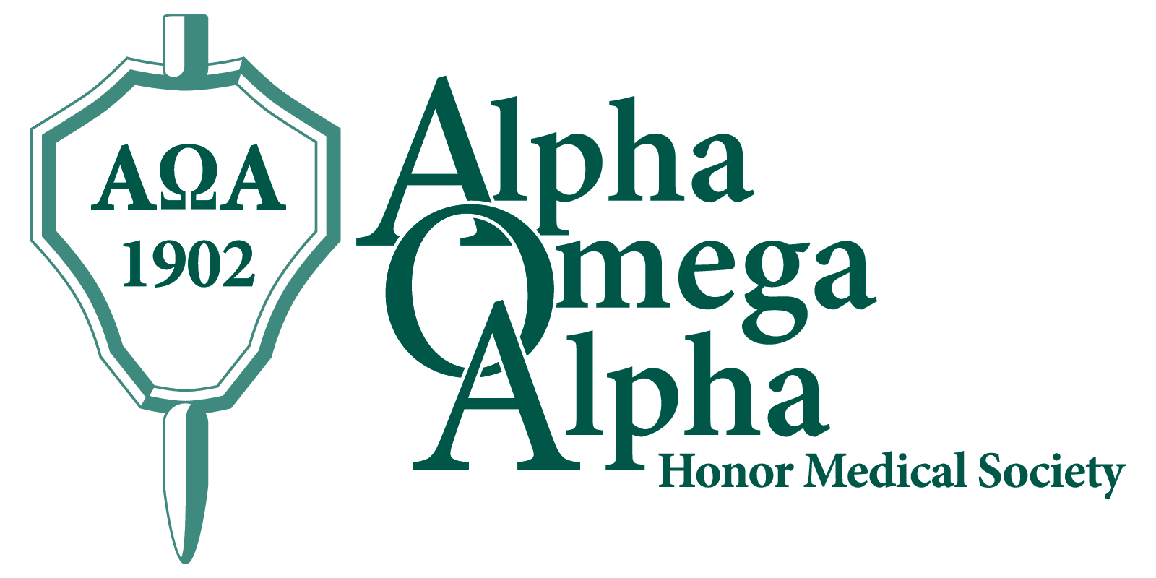

Press Release

USF Morsani Students Named to AOA Honor Medical Society

Tampa, October 3, 2014: Fourteen USF Morsani College of Medicine (MCOM) Class of 2015 medical students were elected to the Alpha Omega Alpha (AOA) honor medical society in the 2014 fall election cycle. Twice a year, the AOA Gamma Chapter at USF MCOM elects new members, chosen from the top quartile of the class, based on criteria of academic performance, leadership, service, and professionalism. A total of one-sixth of the class may be chosen. The society’s motto is “Be worthy to serve the suffering.”
Membership in AOA is considered to be one of the highest academic honors a student can receive and is a distinction that accompanies a physician throughout his or her career.
Congratulations to the following fourteen USF MCOM Class of 2015 students who will be formally inducted at the AOA Gamma Chapter annual spring banquet:
Ms. Rachel Diane Appelbaum
Mr. Jonathan Braue
Ms. Jae Chung
Mr. Kevin Cronin
Ms. Brittany Diane Darragh
Mr. Michael Irick
Mr. Kirk Jeffers
Mr. Stephen Mayper
Ms. Jessica Ashley Rainey
Mr. Jason Ricciuti
Mr. Eric Warren Rudnick
Mr. Sean Spence
Ms. Jaimie Weber
Ms. Amanda Zimmerman

They will join their following Class of 2015 classmates who earned the prestigious honor of being elected as juniors:
Mr. Justin Abbatemarco
Mr. Stephen Aradi
Mr. Michael Cameron
Mr. Christopher Centonze
Ms. Jennifer Harb, AOA Gamma Chapter Vice President, Class of 2015
Mr. Andrew Hayden, AOA Gamma Chapter President, Class of 2015
Mr. Thomas Hayman
Mr. Grey Leonard
Mr. Christopher Russell

Founded in 1902, the Alpha Omega Alpha Honor Medical Society is the only national honor society for medicine in the United States and has 123 chapters in medical schools throughout the United States. AOA exists to promote scholarship and research in medical schools, encourage a high standard of character and conduct among medical students and graduates, and recognize high attainment in medical science, practice, and related fields. The AOA Gamma Florida Chapter at Morsani College of Medicine was established in 1976.

http://hsc.usf.edu/nocms/medicine/aoa/home.htm
www.alphaomegaalpha.org

