Instructions for redeeming GAYF app PIN codes
Step One
In order to redeem the PIN code for your subscription to the Geriatrics at Your Fingertips app, you must first log into a user account on www.GeriatricsCareOnline.org.
If you are not an AGS member, and do not already have a GeriatricsCareOnline user account, please click the Non Member tab in the login area and sign up for an account using the Register Now link. After you have registered, sign in using the Non Member tab with the username and password you just set up at registration.
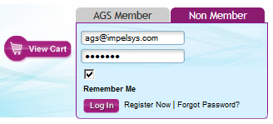
If you are an AGS member, you do not need to sign up for a new account. Your username and password are the same credentials you use to log into MyAGS. Sign in using the AGS Member tab in the login box in the upper right corner of the screen.
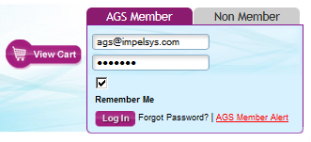
Special Notice: Some users may try to access GeriatricsCareOnline from a computer in a location that already has an institutional license. If this is the case, you will see a Welcome message in the upper right hand corner with the institution name instead of the sign-in options described above:
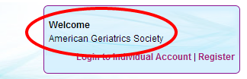
If you are an AGS member, or already have a GeriatricsCareOnline Non Member user account, click the Login to Individual Account link and follow the sign-in directions above.

If you are not an AGS member and do not have a GeriatricsCareOnline Non Member user account, click the Register link to create a new account. Then click the Login to Individual Account link and follow the sign-in directions above.

You will know you are successfully logged in when you see the Welcome message with your name in the upper right corner instead of the log in fields.
Step Two
Once you are logged in, you can access the GAYF app by visiting the Store tab. Scroll down to the Mobile Apps section, and you will find the listing for the GAYF app. (You can also go to the app directly at this link.)

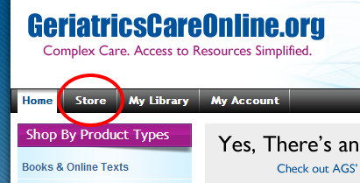

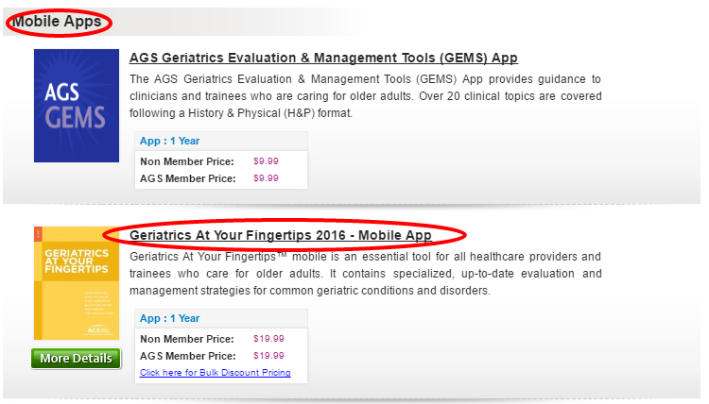

Click on the “Geriatrics At Your Fingertips 2017 - Mobile App” title – this will bring you to the Product Details page. To the right of the Product Details header, there is a button marked Activate PIN. Please select the button and enter your PIN code to activate your online subscription to the GAYF app.
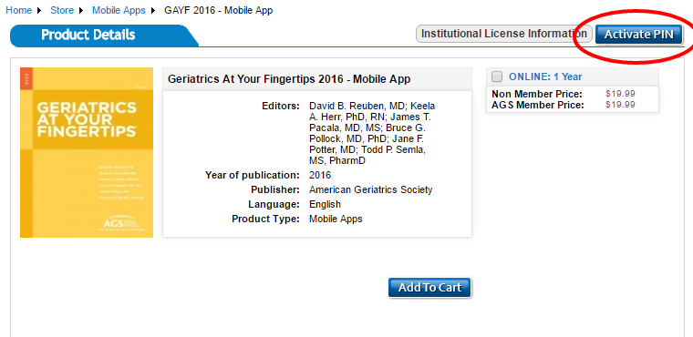

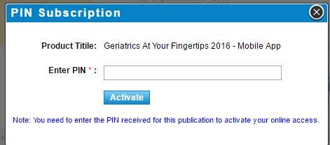

Special Notice: If the Activate PIN button does not appear on the Product Details page, make sure you are logged in; the button will not be visible if you are not logged into a user account. If you are logged in and cannot see the Activate PIN button, try clearing the cache on your browser (http://www.wikihow.com/Clear-Your-Browser's-Cache) and then refreshing the page.

Step Three
Once you activate the PIN code, you will automatically be directed to the My Library tab (located in the black bar near the top of the page).

In the My Library tab, you will see an entry for the GAYF app. Click the orange Download button. You will be given the option to download the app from the App Store (for Apple products) or the Google Play store (for Android products).

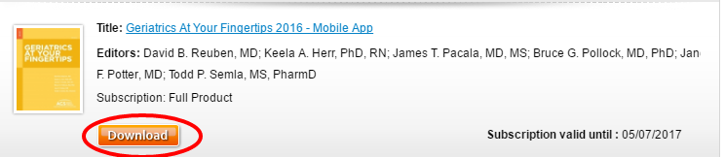
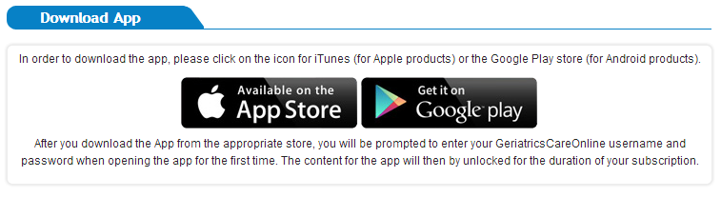

After you download the app from the appropriate store, you will be prompted to enter your GeriatricsCareOnline username and password when opening the app for the first time. The content for the app will then be unlocked for the duration of your subscription.

For questions or assistance, please contact Aimee Cegelka at
GCOinfo@americangeriatrics.org or 212-308-1414.

