Contact:  Catherine M. Lynch, M.D.  AOA Councilor, Gamma Florida Chapter  USF Morsani College of Medicine  Phone: (813) 974-1582 | 12901 Bruce B. Downs Blvd MDC2  Tampa, FL 33612 | 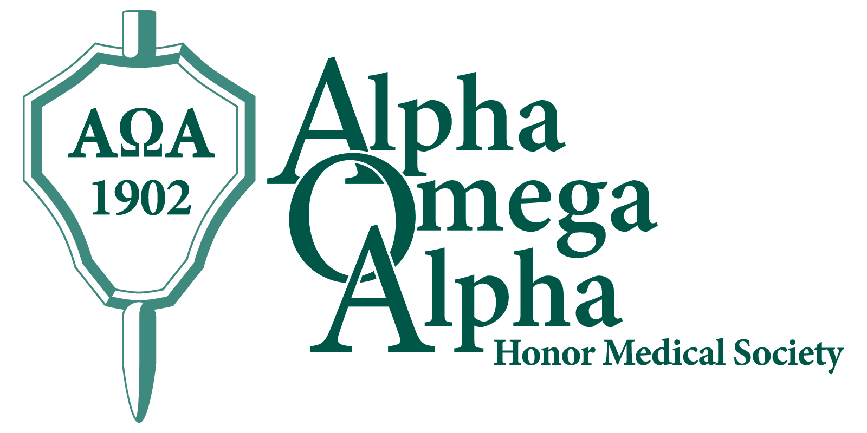

Press Release

USF Morsani Students, Alumni, Faculty, Residents Named to AOA Honor Medical Society
Tampa, September 8, 2016: Fourteen USF Morsani College of Medicine (MCOM) Class of 2017 medical students were elected to the Alpha Omega Alpha (AOA) honor medical society in the 2016 fall election cycle. Twice a year, the AOA Gamma Chapter at USF MCOM elects new members, chosen from the top quartile of the class, based on criteria of academic performance, leadership, service, and professionalism. A total of one-sixth of the class may be chosen. The society’s motto is “Be worthy to serve the suffering.”
Membership in AOA is considered to be one of the highest academic honors a student can receive and is a distinction that accompanies a physician throughout his or her career.
Congratulations to the following 14 USF MCOM Class of 2017 students who will be formally inducted at the AOA Gamma Chapter annual spring banquet:
Mr. Himanshu Ajrawat | Mr. Matthew Beattie | Ms. Rebecca Gean Grown (LVHN)
Ms. Camila Cabrera | Ms. Carly Crowder (LVHN) | Ms. Tiana Meagan Dalton Guillaume (LVHN)
Ms. Palma Belle Irizarry | Ms. Emma Kate Jones (LVHN) | Mr. Philip Palmon
Ms. Richelle Marie Reinhart (LVHN) | Mr. Samuel Oscar Slone | Ms. Thejal Srikumar
Mr. Augustine Reid Wilson | Mr. Matthew Gary Witzel

They will join their following Class of 2017 classmates who earned the prestigious honor of being elected as juniors:
Mr. Kyle Achors | Mr. Nigel James Arruda
Mr. Steven Paul Baltic (LVHN) | Mr. Jacob J. Benedict**
Mr. Luis Enrique Gonzalez | Mr. Alexander Warren Dalton Guillaume (LVHN)
Mr. Peter Maher Hannah | Ms. Thuy-Quynh “Jennifer” Le
Ms. Kathleen McFadden (LVHN) | Mr. Andrew Mason Mehlman
Ms. Maysson Muftah | Mr. George Joseph Richard
Ms. Cady Welch* | *Chapter President 2017
 | **Chapter Vice President 2017

Annually, the spring nominations may include Residents, Fellows, Faculty, and Alumni. We congratulate the following individuals on their election to AOA:
Dr. Isabel Gross (Resident) | Dr. Brian Christopher Kellogg (Resident)
Dr. Michael Joseph La Rock (Faculty, LVHN) | Dr. James Calhoun Mayer (Faculty)
Dr. Lynette J. Menezes (Faculty) | Dr. Kellee Oller (Faculty)
Dr. Alexandra T. Strauss (Resident) | Dr. Kaley M. Tash (Fellow)
Dr. Kenneth Joseph Visalli, Jr. (Resident) | Dr. Kira Katherine Zwygart (Alumni)

Founded in 1902, the Alpha Omega Alpha Honor Medical Society is the only national honor society for medicine in the United States and has 130 chapters in medical schools throughout the United States. AOA exists to promote scholarship and research in medical schools, encourage a high standard of character and conduct among medical students and graduates, and recognize high attainment in medical science, practice, and related fields. The AOA Gamma Florida Chapter at Morsani College of Medicine was established in 1976.
USF MCOM: University of South Florida Morsani College of Medicine
LVHN: Lehigh Valley Health Network
http://hsc.usf.edu/nocms/medicine/aoa/home.htm
www.alphaomegaalpha.org

