Resident Research Day
June 17, 2011
Program

Time | Topic | Speaker
 | Moderator: Catherine Lynch, M.D.
1:00-1:15 | Comorbidities of the Super Obese in Pregnancy. | Jeanmarie Texier, M.D.
1:15-1:30 | Ultrasound Detection accuracy for 2 Vessel Umbilical Cords | Eva Crooke, M.D.
1:30-1:45 | Term PROM with Unfavorable Cervix: Misoprostol Vs Oxytocin | Karen Matta-Toomey, M.D.
1:45-2:00 | Resident Education in Gynecologic Robotic Surgery | Ashley Cain, M.D.
2:00-2:15 | Counseling Patients for VBAC | Hillary Kufahl, M.D.
2:15-2:30 | BREAK
 | Moderator: J Kell Williams, M.D.
2:30-2:45 | Survival with Mucinous Vs Serous Ovarian Cancer | Ingrid Ramirez, M.D.
2:45-3:00 | Incidence and Risk Factors for Vaginal Cuff dehiscence after Minimally Invasive Surgery | Kristie Greene, M.D.
3:00-3:15 | Noninvasive Assay of Sperm Quality | Farah Sultan, M.D.
3:15-3:30 | Closure of the peritoneum at Cesarean Section: Does it make a difference | Siobhan Bertolino, M.D.
3:30-3:45 | Local Trends in Prenatal and Post Partum Contraception Counseling | Rebecca Todd, M.D.
3:45-4:00 | BREAK
 | Moderator: Mitchel Hoffman, M.D.
4:00-5:00 | Potential Pitfalls and Traps in the Practice of Gynecology | Michael A. Finan, M.D.  Professor GYN Oncology  University of South Alabama

USF
University of
South Florida

College of Medicine

Department of Obstetrics
and Gynecology

_________________________
RESIDENT RESEARCH DAY
_________________________

Friday, June 17, 2011
1-5 p.m.
The William C. MacInnes Auditorium
Second Floor
Tampa General Hospital

Visiting Professor
Michael A. Finan, M.D.
Chief of Gynecologic Oncology
Professor of Interdisciplinary Clinical Oncology
University of South Alabama
Mobile, Alabama

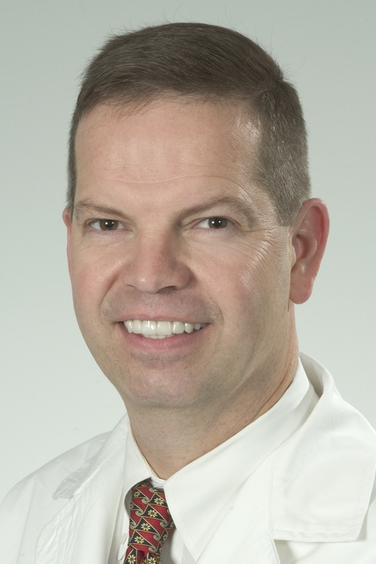

Dr. Michael Finan was born in New Orleans. He received his M.D. Degree from Louisiana State University in Shreveport, LA in 1986 and he did his residency in Obstetrics and Gynecology at USF in Tampa from 1986-1990. He was the Chief Administrative Resident in 1989-1990 and in 1990 won the first place Resident Research Award. He then did a fellowship in Gynecologic Oncology at USF H. Lee Moffitt Cancer Center from 1990-1992. He is now Professor and Chief of Gynecologic Oncology at the University of South Alabama in Mobile.

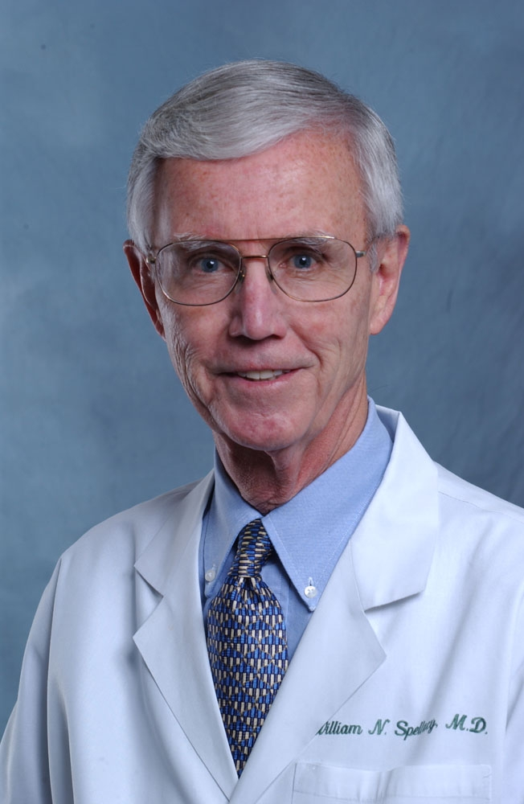

William N. Spellacy, M.D.

William Nelson Spellacy was born in St. Paul, Minnesota and attended the University of Minnesota for his undergraduate education and medical school, graduating with Alpha Omega Alpha honors. He also completed his residency in Obstetrics and Gynecology there.

His professional academic career began as a faculty member at the University of Minnesota, from which he moved to the University of Miami and advanced to the academic rank of Professor. While still in his thirties, he was appointed Professor and Chairman of Obstetrics and Gynecology at the University of Florida School of Medicine, where he remained for almost a decade. In 1979, Dr. Spellacy moved to Chicago to head the Department of Obstetrics and Gynecology at the University of Illinois. Under his leadership, the department achieved national prominence in research, education and patient care. In 1988, he returned to Florida to become Chairman of the Department of Obstetrics and Gynecology at the University of South Florida College of Medicine. In 2002 he resigned the chairmanship and has continued as Professor and Residency Director.

In addition to being chairman of three academic OB/GYN departments, he was one of the main architects of the design and formation of the original subspecialty of Maternal Fetal Medicine. His contributions to medical literature have been impressive in both quality and quantity, with over 500 peer reviewed articles, 80 book chapters, and 10 books resulting from his efforts. He has been the recipient of numerous honors and recognitions, including being elected to the Institute of Medicine of the National Academy of Sciences, one of the highest honors in medicine. He has served as President of the Society for Gynecologic Investigation (SGI), the Association of Professors of Gynecology and Obstetrics (APGO), and the Society of Maternal Fetal Medicine (SMFM). He was also a director of the American Board of Obstetrics and Gynecology (ABOG). While his interests are varied, he has always placed an emphasis on resident and student education, and research in areas of Women Health.

