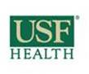

USF GME House Staff Benefits

**Health Insurance**

**United Health Care Three Tier Choice Plus**

* Resident portion of coverage is paid for by the USF Morsani College of Medicine (MCOM). Coverage starts on your first day of work. Dependent elections can be added at a low cost of $50 per month for spouse only; and $75 per month for spouse and/or eligible dependent child(ren). Dependent coverage is payroll deducted.
  + - **Tier 1 (USF MCOM Physicians and Affiliated Hospital Sites)**
      * Co-Payment: None
      * Deductible: None
      * List of MCOM (Tier 1) Providers: <http://health.usf.edu/doctors/>
    - **Tier 2 (UHC Provider)**
      * Co-Payment: $20 per outpatient visit
      * Deductible: $250
      * List UHC (Tier 2) Providers: [www.myuhc.com](http://www.myuhc.com)
    - **Tier 3 (Out of Network Provider)**
      * Co-Insurance: 20% after deductible
      * Deductible: $500

**Disability Insurance**

**Standard Insurance Company**

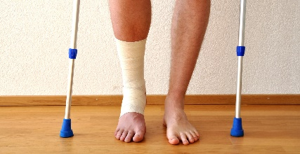The USF MCOM pays the premium for a Long-Term Disability (LTD) plan designed to provide you with income protection in case of a disability during your training. You will be enrolled in this plan automatically at time of hire.

Your LTD pays a benefit of $2,500 per month after a period of disability of 90 days.

Once disability coverage is active, you will receive your monthly benefit for as long as you are disabled, up to age 67.

**Life and Accident Insurance**

**Standard Insurance Company**

A $50,000 group term life insurance policy is provided to you by Standard Insurance Company and paid for by the USF MCOM.

**Retirement**



**Basic Retirement Plan**

USF Residents/Fellows are automatically enrolled into the Temporary Employee Retirement Plan (TERP). **Participation in TERP is mandatory.**

* TERP is a defined contribution plan authorized under Section 401(a) of the Internal Revenue Code.
* **VALIC** is the plan administrator for the University of South Florida. Full information is available on the USF HR website: <http://www.usf.edu/hr/benefits/retirement/terp.aspx>
* 7.5% of pretax wages will be taken biweekly with each pay period.
* Please note that, by default, you are enrolled in a low risk option. However, you may change your designated funds by contacting VALIC at 1-800-448-2542 for instructions on how to set up your online account.
* You can access your VALIC account, [www.valic.com](http://www.valic.com). Click on **Register,** and provide the requested information or **Sign In** if you already have a VALIC account.
* You can also call the VALIC Client Services Office by calling 1-800-448-2542 (M-F, 8:30 a.m. – 5:00 p.m. EST) to access your account.

**Optional Voluntary Retirement Plans**

In addition to TERP, USF offers optional opportunities to save for retirement utilizing 403(b) Tax Sheltered Annuities and 457 Deferred Compensation Plans. These programs offer employees the opportunity to save additional money for retirement while reducing current income tax liability. Contributing to a tax-deferred program is voluntary. Contributions are made through payroll tax deduction and forwarded to a participating investment company. For additional information on these voluntary tax-sheltered annuity options – and a list of participating companies, visit <http://usfweb2.usf.edu/human-resources/benefits/tsa.asp>.

**Dental Insurance Plans**

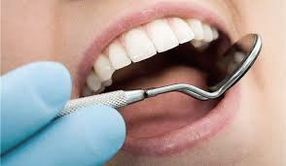As a USF Morsani College of Medicine resident/fellow, you are eligible to enroll in one of three United Healthcare Dental Plans designed to meet your unique needs based on plan usage, flexibility in using network or non-network dentists and cost. The dental plans are divided into three categories: Primary PPO Plan ([PPO30](https://usf.box.com/s/sf377wjktavekd0p5jes7abn16sady78)), Alternate PPO Plan ([PPO20](https://usf.box.com/s/4splf78x8tkn22kmsx3opzjpx2kjghnx)), and [DHMO](https://usf.box.com/s/9praquosznbgradh0mvylfx42vkdps1r).

For PPO Plans, you can receive care from any dentist, but your cost is lower when you use network providers. To find an in-network dentist, go to myuhc.com/dental (be sure to select the applicable plan, i.e. PPO30 or PPO20). You will have an annual deductible to meet before the plan starts paying benefits, and then you pay part of the cost for the services you receive.

The DHMO Plan pays benefits only when you use a network provider. There is no deductible or annual maximum. You pay a fixed copayment for dental procedures listed on the co-payment schedule.

These dental plans are voluntary, paid entirely by the employee (you) via payroll deduction.

**Vision Insurance Plans**

**Vision, Dental, Flexible Spending Accounts**

Affordable vision coverage is available to eligible employees through United Healthcare. The plans cover exams and materials at significantly reduced rates. Vision plans include network and non-network coverage options with allowances towards lenses or contacts every twelve months and frames every 24 months. The plan’s Laser Vision correction procedures are offered at discounted rates when performed by Laser Vision Network of America (LVNA) providers.

[Vision insurance](https://usf.box.com/s/zxov9865cm4z74ighwxh208jyw6qzfgs) is voluntary, paid entirely by the employee (you) via payroll deduction.

**Transportation Services**



USF Health and GME are committed to the safety, well-being, and fatigue mitigation of all our residents and fellows. To that end, we offer a variety of transportation service options, such as taxi vouches, Uber or Lyft reimbursements.

For additional information on transportation service options, go to: health.usf.edu/medicine/gme/current/taxi-services.

**Wellness**



Wellness programs are offered to USF MCOM residents on a regular basis. Watch your email for details on these programs.

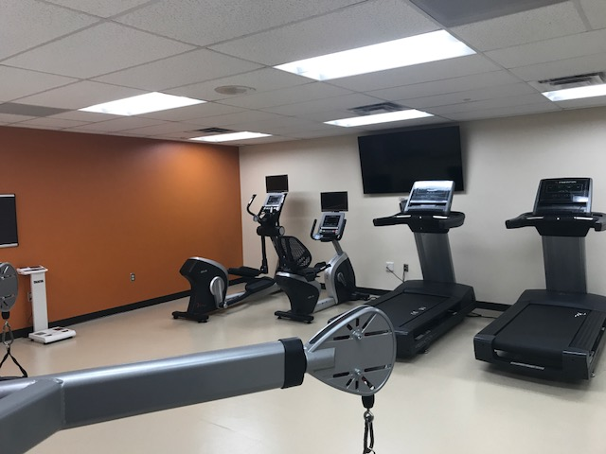Staying physically active is an important key to support wellness, but it can be tough with all the demands placed on a residents’ time. In an effort to increase wellness and resiliency during medical training, the USF MCOM offers access to a 12,000 square-foot, full-service, state-of-the-art fitness center located on the USF Health campus. The WELL Fitness Center is located near the Morsani Center for Advanced Healthcare, Moffitt Cancer Center, and the James Haley VA Hospital. The discounted membership for residents is $90 per year.

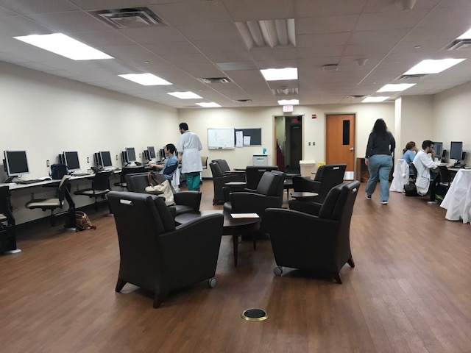For residents and fellows who are working on the south side of Tampa, Tampa General Hospital (TGH) offers a 5,000 square-foot fitness center for a nominal fee.

In addition, there is a free gym in the TGH resident lounge located on the 4th floor of the hospital.

**Resident Assistance Program**

As a resident/fellow at USF Health, your well-being is important to us, both on and off the job. The Resident Assistance Program (RAP) is a service established through non-University providers to assure privacy and freedom from interaction with colleagues or supervisors. RAP is committed to assisting residents and fellows in any area of their personal and professional life so that they may go through training in a balanced, growth producing manner. Your contact with RAP is confidential and provided within the parameters of professional ethics and applicable state/federal laws.

You and/or each of your dependents are provided up to eight (8) visits per year at no charge. For additional information on this benefit, visit the GME website: <http://health.usf.edu/medicine/gme/current/resident-assistance-program>

The University of South Florida operates on a bi-weekly payroll cycle. Each pay period begins on Friday and ends two weeks later on Thursday. You are paid for that pay period one week later on Friday. As a condition of employment, USF requires that all employees enroll in direct deposit through GEMS Self Service. USF uses Duo, a multi-factor authentication system to add an extra layer of security to your account. To set up your Duo Authentication, go to <http://netid.usf.edu/duo>. Duo adds an additional step during GEMS Self Service login to help keep you safe while being online. You can also view a PDF of the full Duo instruction guide at <http://www.usf.edu/it/documents/duo-details.pdf>.

**Payroll**

Once Duo is set up, log onto my.usf.edu using your Net ID and password. Click on Business Systems and select GEMS from the drop down menu, then select **Self Service** in the left column. Next select **Payroll and Compensation¸**to enter your banking information. You can also use GEMS Self Service to view and print your bi-weekly pay, update your address and/or W-4 allowances.

For more information on house staff benefits, or the current salary schedule, please check the GME website, <http://health.usf.edu/medicine/gme/> or email [Patti Taylor](mailto:ptaylor@health.usf.edu?subject=Benefits) [ptaylor@health.usf.edu](mailto:ptaylor@health.usf.edu)



**Shimberg Library**

To facilitate the research needs of USF GME Residents and Fellows, you can place requests for automated article scans, document delivery, and Inter-Library Loan materials through ILLiad at no cost to them. Simply log into ILLiad, http://www.lib.usf.edu/ill/, with your USF NetID, and specify Shimberg Health Sciences Library, to request your materials.

Other benefits/services/resources available to you at the Shimberg Library include Library resources (e.g. journals, databases, books, media), use of the library computer lab, and more! Log on for additional information, <http://library.hsc.usf.edu/>.

**Resident and Fellow Leave Information**

**Annual (Vacation) Leave.** All USF GME Residents and Fellows receive fifteen (15) weekdays of annual leave per contract year. Vacation is pro-rated for trainees beginning mid-cycle.

**Sick Leave.** All USF GME Residents and Fellows receive nine (9) weekdays of sick leave.

**Maternity/Paternity Leave.** All USF GME Residents and Fellows are eligible for up to 10 days of compensated maternity/paternity leave. This leave should be taken within 90 days of the birth or adoption of a child.

**Family Medical Leave Act (FMLA).** USF GME Residents and Fellows are entitled to the provisions of the Family Medical Leave Act of 1993. This leave is without pay, but accrued annual, sick, maternity/paternity leave may be used in conjunction with FMLA. In order to be considered eligible under the FMLA guidelines, a resident must (1) have worked for the University for at least 12 months; and (2) have worked at least 1,250 hours during the year preceding the start of the leave.

**Military Leave.** Residents and Fellows who are members of any reserve component of the armed forces of the United States will be granted leave for active duty training, not to exceed 30 calendar days per year. Residents on active duty training are compensated by the military and not by the University during this period; however benefits are continued.

**Bereavement Leave.** USF GME Residents and Fellows may be granted three (3) days of Bereavement Leave in order to attend the funeral services of immediate family and to assist in estate settlement. Immediate family includes spouse, domestic partner, child or step child, parent or step parent, brother, sister, grandparent, grandchild. A miscarriage is included in this definition of death in the immediate family.

**Resident Sick Leave Pool.** The purpose of the Sick Leave Pool is to provide emergency paid sick leave to a USF GME resident/fellow who has suffered an unexpected personal illness, surgery, injury, or disability with complications beyond their control and who have exhausted their personal sick leave. By definition, “unexpected personal illness” does not include uncomplicated pregnancy or recovery following childbirth.