Performance Improvement Plan Template
One component of the application that typically involves multiple drafts is the Performance Improvement Plan. I’ve included the 5 questions that you will be asked to complete so that you can begin on a Word document. Once this is complete, we can then copy and paste your responses into the application. You will find that I’ve provided you with an example response, as well as a character limit, for each question. Please follow the structure of the examples when drafting your responses, as this will allow consistency for the reviewers.
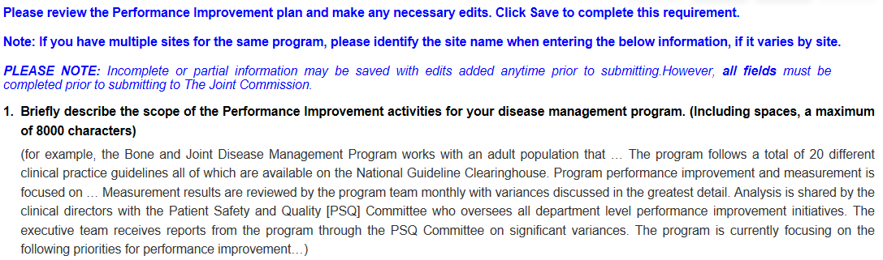
(Draft your response here)

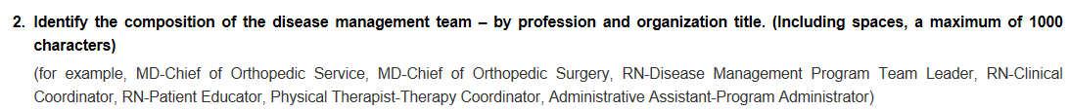
(Draft your response here)

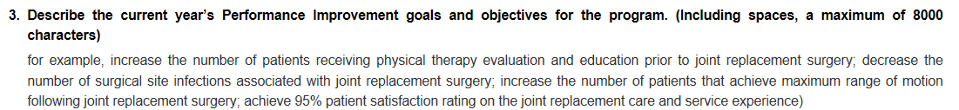
(Draft your response here)

(Draft your response here)

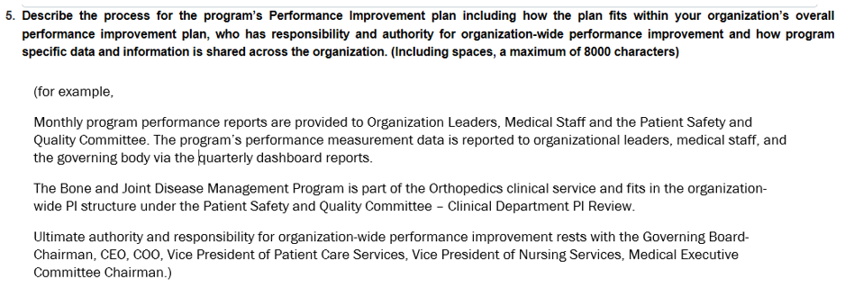
(Draft your response here)

