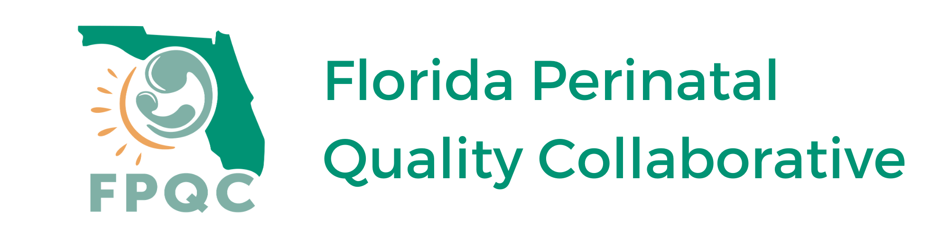
Florida Levels of Maternal Care (LOMC) Program
Quick Start Checklist
FIRST
  - Review FPQC LOMC website (fpqc.org/lomc) to understand goals and steps for LOMC verification
- Online description and materials
- Overview slide set and webinar recording
- The Joint Commission Levels of Maternal Care Verification website (jointcommission.org/what-we-offer/verification/maternal-levels-of-care-verification)
  - Obtain administrative buy-in for LOMC verification
- Florida LOMC one-pager
- Florida LOMC Overview for Hospitals (PowerPoint presentation)
- Request assistance from FPQC champions at fpqc@usf.edu
  - Identify administration, accreditation/quality improvement, nursing, and OB champions to serve on hospital LOMC team
NEXT
  - Review, complete and return FPQC LOMC Funding Application & Hospital Commitment Form*
  - Schedule regular team meetings and develop communication plan to keep stakeholders updated on progress of verification process
  - Create Gantt Chart to track progress/assign responsible parties
  - Keep track of questions from team
  - Contact Brian Johnson at bjohnson@jointcommission.org or (630) 792- 5144 at the Joint Commission (TJC) to obtain LOMC verification standards
  - Complete gap analysis comparing the LOMC Verification Standards & Elements of Performance and the level you want to attain
  - Review LOMC Verification Comparison Grid to determine desired level of care for application
  - Contact Brian Johnson at to request assistance to begin verification process
  - Route TJC LOMC contract for signature and return
  - Review the Florida LOMC Playbook for potential resources to assist with addressing identified gaps
  - Schedule virtual call with LOMC nursing mentor to discuss preparation, application, site visit and any questions from the team
  - Submit TJC LOMC Verification Application including identifying site visit ready date
  - Alert hospital finance department that TJC will invoice them for LOMC verification, but FPQC will pay
ONGOING
- Provide information about LOMC (flyer, presentation, description) to appropriate departments in preparation for LOMC site visit
- Upload all required Policies/Order sets into one shared drive or folder in preparation to upload to TJC shared drive
- Prepare for LOMC site visit (see LOMC Site Visit Checklist)
- Reach out to FPQC and/or TJC for help, and celebrate successes with your team, early and often
*All LOMC Program Resources are available at https://health.usf.edu/publichealth/research/chiles/fpqc/lomc

