Contact:  Catherine M. Lynch, M.D.  AOA Councilor, Gamma Florida Chapter  USF Morsani College of Medicine  Phone: (813) 974-1582 | 12901 Bruce B. Downs Blvd MDC2  Tampa, FL 33612 | 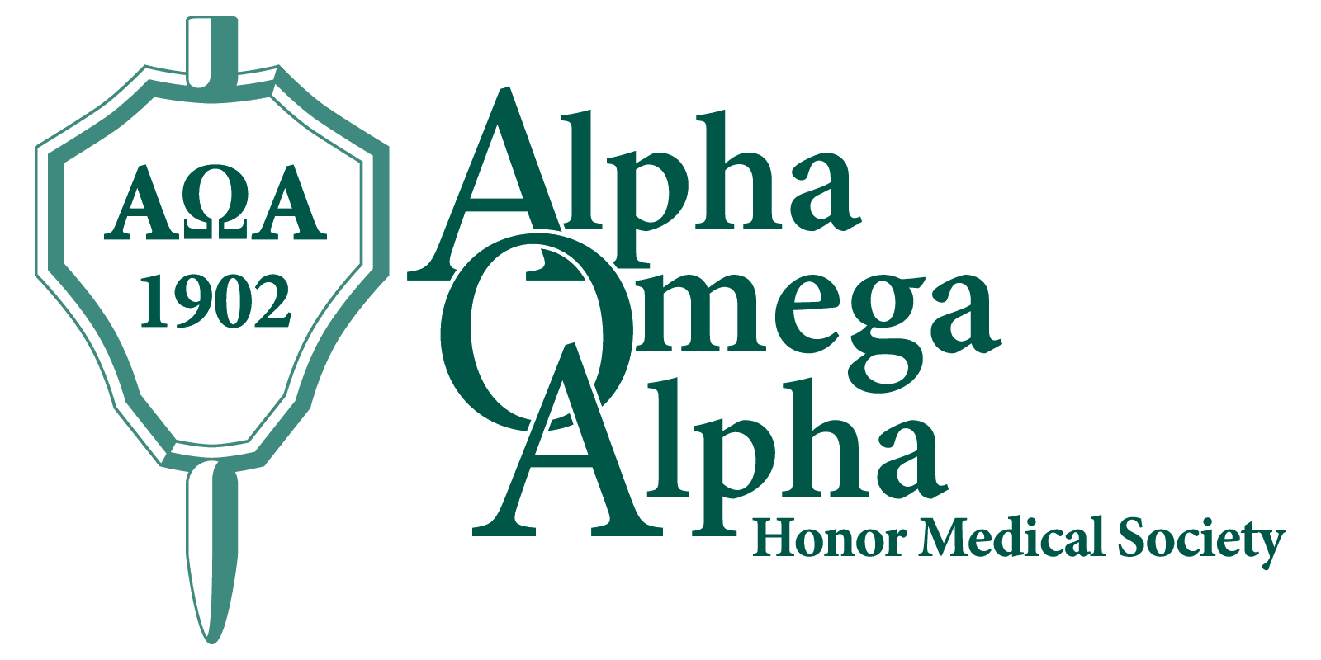

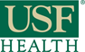 Press Release

USF Morsani Students, Alumni, Faculty, Residents Named to AOA Honor Medical Society
Tampa, March 25, 2015: Nine USF Morsani College of Medicine (MCOM) Class of 2016 medical students have earned the prestigious honor of being elected as juniors to the Alpha Omega Alpha (AOA) honor medical society in the 2015 Spring election cycle. Twice a year, the AOA Gamma Florida Chapter at USF MCOM elects new members, chosen from the top quartile of the class, based on criteria of academic performance, leadership, service, and professionalism. A total of one-sixth of the class may be chosen. The society’s motto is “Be worthy to serve the suffering.”
Membership in AOA is considered to be one of the highest academic honors a student can receive and is a distinction that accompanies a physician throughout his or her career.
Congratulations to the following nine USF MCOM Class of 2016 students who will be formally inducted at the AOA Gamma Florida Chapter annual spring banquet:
Mr. John Derek DeNigris | Ms. Kathleen Pombier
Mr. Nick James (LVHN) | Ms. Elizabeth Nicole Teal
Mr. Jonathan Koscso | Mr. Matthew R. Thau (LVHN)
Ms. Taylor Martin | Mr. William Christian Thomas
Ms. Bindiya G. Patel

In addition, the following alumni/ae, faculty, and residents were selected to AOA Gamma Florida Chapter in recognition of their achievements and contributions to the USF Morsani College of Medicine in the traditions of Alpha Omega Alpha:

Alumnus: | Glenn Catalano, M.D. | USF College of Medicine, 1988
Alumnus: | Eric Emmanuel Coris, M.D. | USF College of Medicine, 1996
Alumna: | Valerie Marie Panzarino, M.D. | USF College of Medicine, 1990
Faculty: | Lucy Guerra, M.D. | Mount Sinai School of Medicine, 1997
Faculty: | Jorge Enrique Marcet, M.D. | Cornell University College, 1985
LVHN Faculty: | Sweety Jain, M.D. | Medical College Calcutta, India, 1983
Resident: | Ashley Helen Davis-Yadley, M.D. | USF Morsani College of Medicine 2013

Founded in 1902, the Alpha Omega Alpha Honor Medical Society is the only national honor society for medicine in the United States and has 123 chapters in medical schools throughout the United States. AOA exists to promote scholarship and research in medical schools, encourage a high standard of character and conduct among medical students and graduates, and recognize high attainment in medical science, practice, and related fields. The AOA Gamma Florida Chapter at Morsani College of Medicine was established in 1976.
USF MCOM: University of South Florida Morsani College of Medicine
LVHN: Lehigh Valley Health Network
http://hsc.usf.edu/nocms/medicine/aoa/home.htm
www.alphaomegaalpha.org

